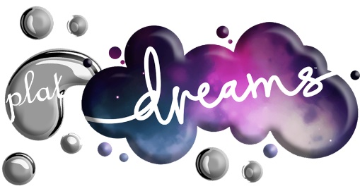

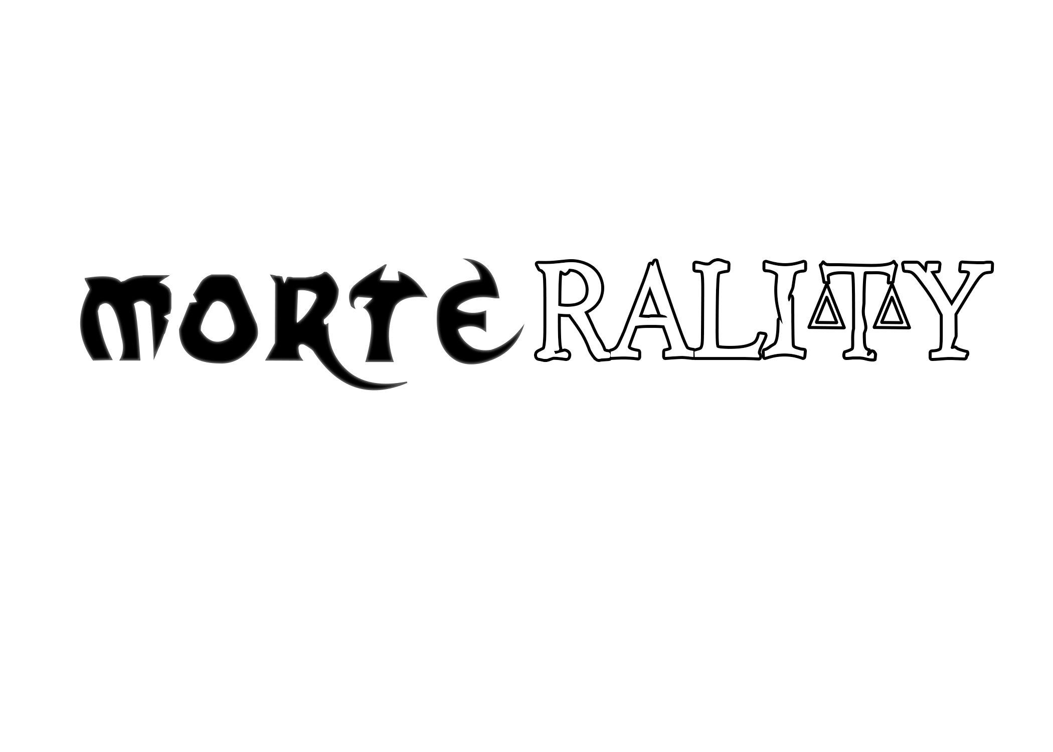

Game Design Document

The following document is a collaboration between:

Tia Nue, Antonino Frazzitta, Damian Hunt, Daniel King, Elliot Ainscough, James Mitschke, Oliver Perkins and Paulo Faria

Production started Monday 3rd February

**© 2020 PlatDreams Ltd.**

Contents

1 Introduction 4

2 Target Market 5

2.1 Don’t Starve 5

2.2 Valiant Hearts: The Great War 6

2.3 Hollow Knight 7

2.4 Marketing data 8

3 Codes and Conventions 12

3.1 Codes 12

3.2 Conventions 13

4 System 14

4.1 Software 14

4.2 Theme 14

4.3 Camera Perspective 14

4.4 User Skills 14

4.5 Difficulty 14

5 Narrative 15

5.1 Structure 15

5.2 Cutscenes 16

5.3 Tone 17

5.4 Environmental Storytelling 17

5.5 Narrative Perspective 17

5.6 Dialogue 17

5.7 Background story 17

5.8 Synopsis 18

5.9 Goal 18

5.10 Characters 18

5.11 Reason for story decisions 19

6 Game mechanics 20

6.1 Pick Ups 20

6.2 Combat System 20

6.3 Abilities 21

6.4 Morality system 23

6.5 Game Length 23

7 Gameplay 24

7.1 Doors 24

7.2 Controls 24

7.3 Game theory applied 27

7.4 Level Navigation 28

7.5 Levels Design 28

7.6 Objective 35

7.7 Losing conditions 35

8 Visuals 36

8.1 Symbolism 36

8.2 Character design 36

8.3 Graphics 40

8.4 Lighting 40

8.5 Colour and mood transition 40

8.6 Locations 41

9 User Interface 44

9.1 Menus 44

9.2 HUD 46

9.3 Hub Map 47

9.4 Screen Navigation Flowchart 48

9.5 Music 51

9.6 Sounds 51

10 Software Testing 52

11 Possible game extensions 53

12 Risk Assessment 54

13 The Team 55

13.1 Team Roles 55

13.2 Meetings and Minutes 55

14 Planning and Gantt chart 61

14.1 Gantt Chart 61

15 References 64

# Introduction

Morterality is a 2.5D action-adventure platformer game based on morality inspired by “Hollow Knight '', “BioShock” and “Valiant Hearts: The Great War ''. It takes place on the ancient Poldoor, a fictional kingdom invaded by the fiends, twisted creatures, once humans whose souls are lost and corrupted.

The player controls Jack, the last of the soul hunters, while going on a quest to save Verity, a young innocent girl. The soul hunter wields a sword that is used to short range strike his enemies.

The player can use different abilities that are absorbed from the bosses if he/she decides to harvest their souls, or either save them. The game story will change based on that decision.

Jack life is represented by ampoules which function as hit points. When Jack’s takes damage by something one ampoule is reduced. If Jack dies it will be teleported in the last checkpoint.

At the start of the game Jack has only “soul trade” ability which can heal himself but by progressing in the game he can expand them to do new things.

By striking the enemies Jack is able to absorb soul energy needed for his soul abilities, this can also be found around the game world.

 that fights twisted creatures, once humans, in each level facing bosses who you can spare or harvest the soul and become stronger.

# Target Market

To be able to confidently produce this game knowing it will be successful requires good market research of similar titles in the same genre. By looking at their statistics, success and audience interest, we can estimate how successful our game will be when targeting certain audiences. This model of research strategy we are using is called a “look-a-like audience” (Justin Carroll, 2017). Below are three similar games that we have analysed.

## Don’t Starve

A survival game with a unique 2D art style in a “3D” world where the player can rotate the camera in 90° snaps:

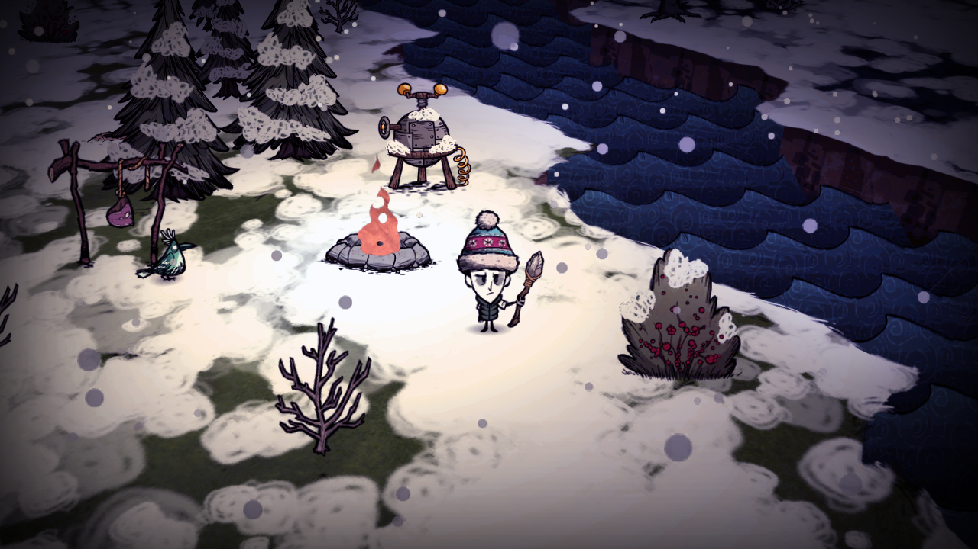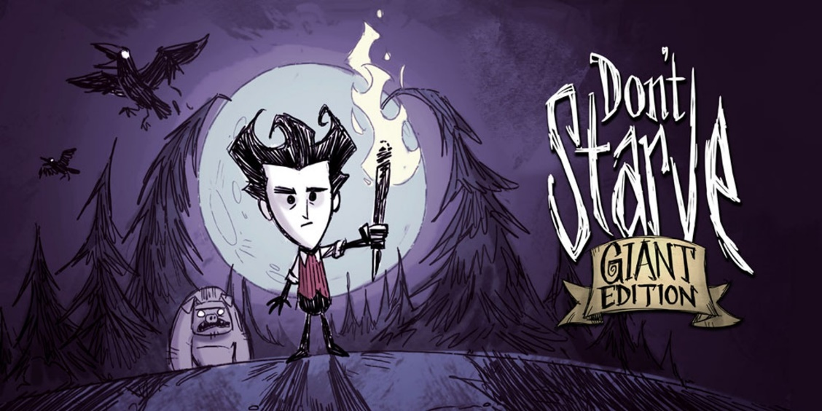

## Valiant Hearts: The Great War

An emotional story heavy game featuring a comic book art style with puzzles and 2D drawings:

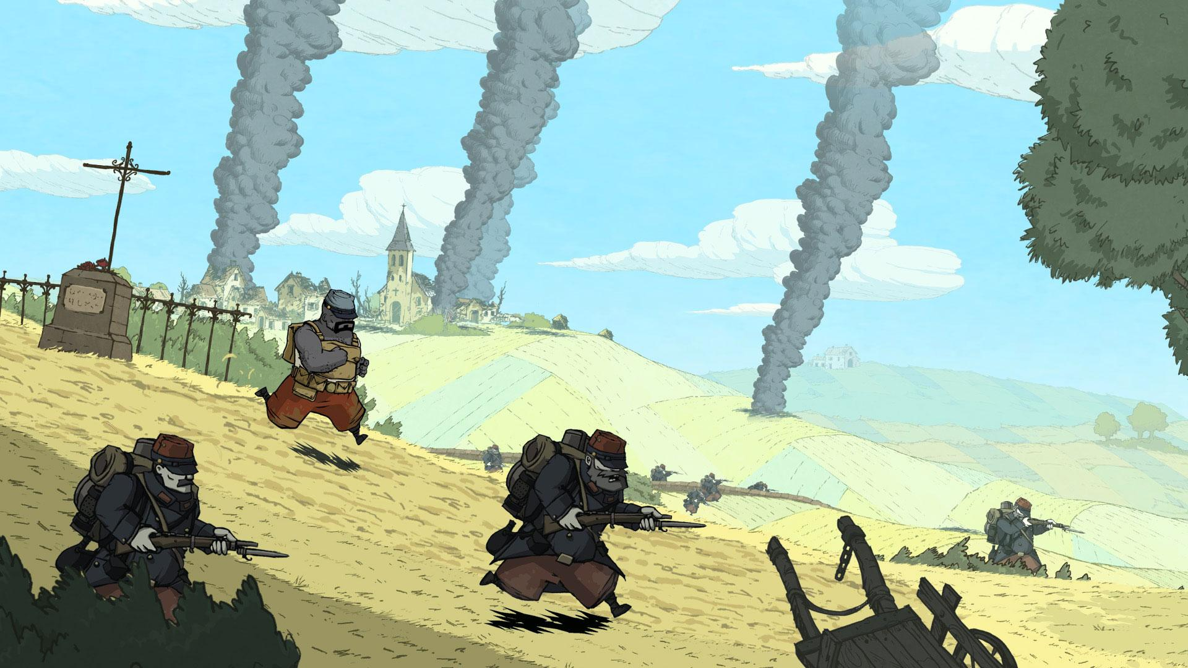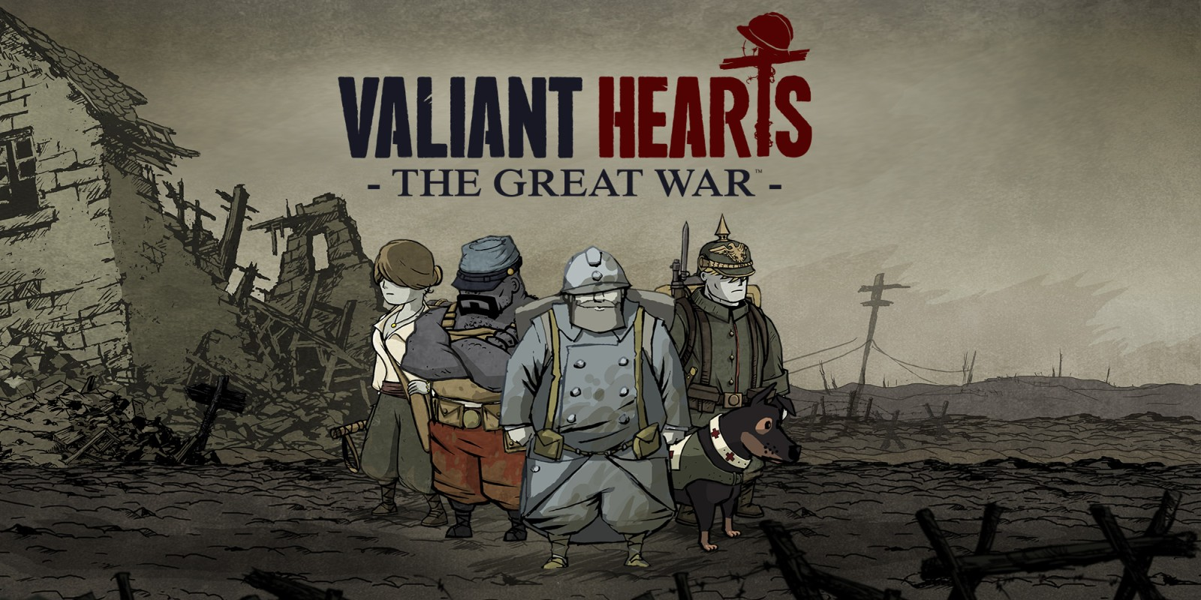

## Hollow Knight

A challenging 2D platformer with a cool 2D art style and visual effects, interesting boss designs and smooth movement and combat:

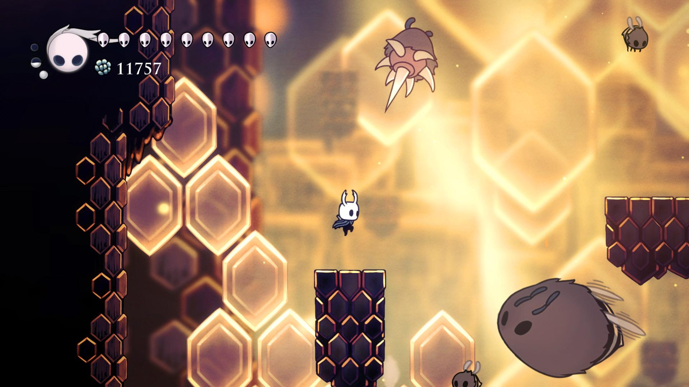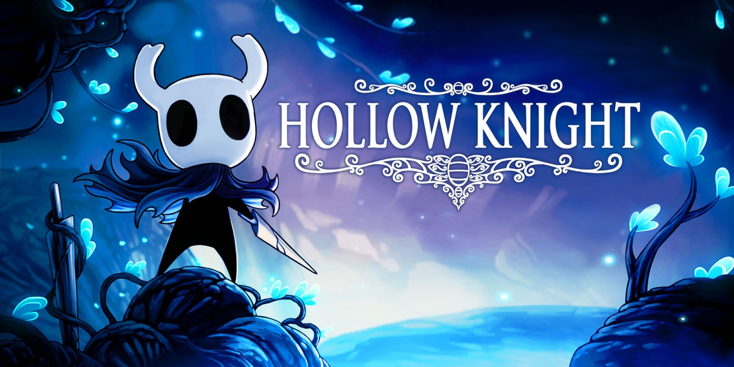

## Marketing data

Overall, our game is a combination of different elements of all three games; we therefore used the average of all the data analysed. The table below shows a general comparison of the games:

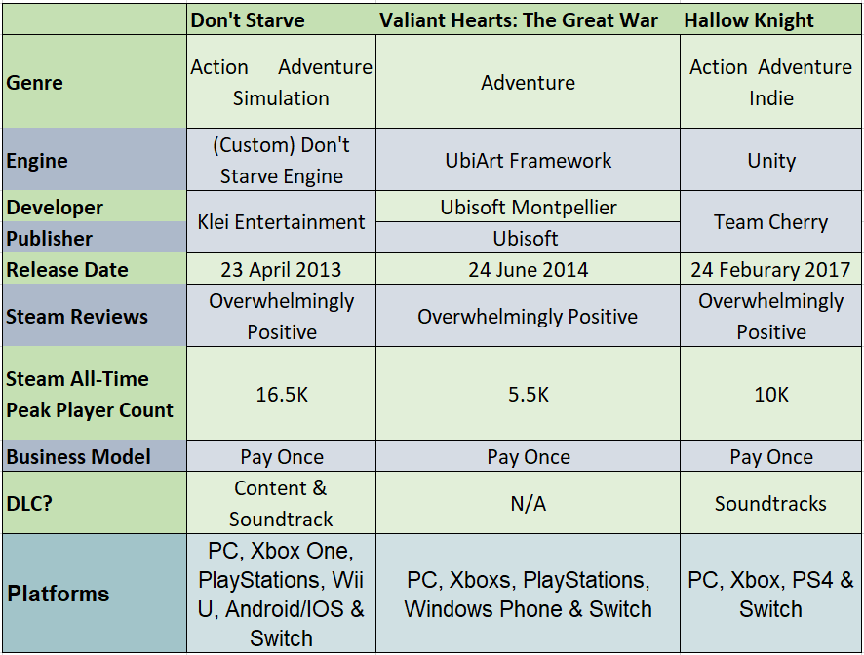

Figure : Basic comparison of the games shown in a table format

From the data above, we can see that they are extremely similar, with the only noticeable difference being Valiant Hearts’ small player numbers. This could be because the game is far more story focused and not very re-playable. While Don’t Starve is a much more re-playable game with very little story, and more focus on procedural world generation and survival. Don’t Starve is also available on the most number of platforms with the highest player count, we can therefore conclude that our target audience is on a range of platforms.

We therefore decided to build the game on the intended platform, PC, and then have additional ports for the game when the initial launch is a success. We furthered compared each game’s success using Google Trends as shown in the figure below:

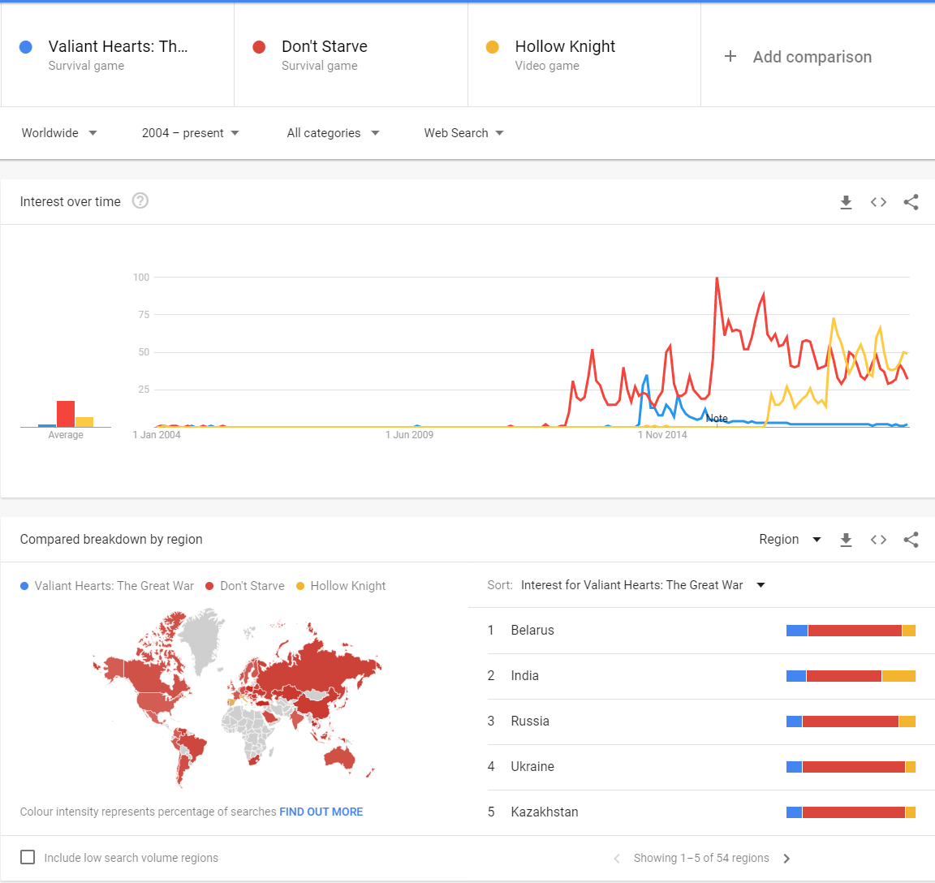

Figure : Images comparing the three games using Google Trends with a global filter of interest over time

From the data above, we can see that Don’t Starve dominated interest over time, due to it releasing before any of the other games and being much more successful. Whilst early success was of a lower interest than Valiant Hearts when that was released, their success was short lived (as with most “one-time experience” games), because its popularity quickly fell within a year. When Hollow Knight was released, it kept up with and surpassed Don’t Starve, which has continued to today.

With an understanding of the basic information and popularity of each game, we then looked at their interest and demographics to identify the audience, using the website SimilarWeb.com to analyse each game’s main website platform. See figure3 below:

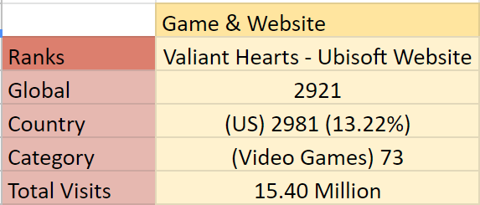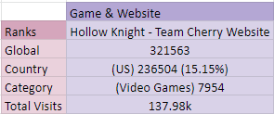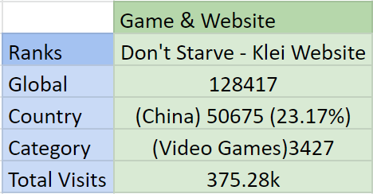

Figure : Comparison of traffic for each game’s main developer website

From the above figure, we can see that our target audience is American gamers with all three, unsurprisingly, being categorised as video game websites. This shows that most of the traffic going to these sites are gamers from America.

To analyse the age and gender of our target audience, we used Facebook’s Audience Insights - the highest percentage (39%) of people interested in adventure games are males aged 25-34. The highest age bracket for women is 32% aged 25-34. This is shown in figure 4 below, which was not filtered on location and had an interest criteria of “Adventure Game”:

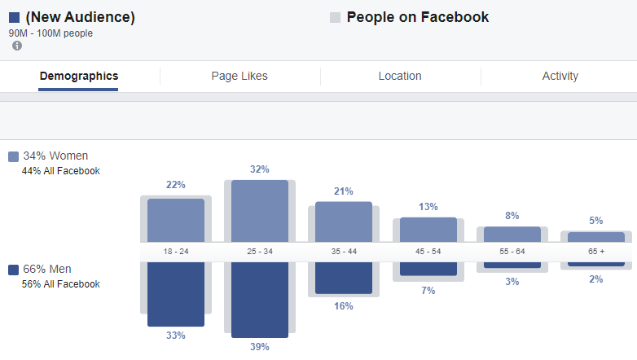

Figure : Facebook Audience Insights showing insight into the gender and age of users interested in adventure games

From this last piece of research analysis, we can confidently say that our target audience is young to middle-aged men in America who are interested in 2D styled adventure games on mainly console platforms.

In addition, our target audience will value re-playability and freedom of choice more in our game, keeping them playing longer, rather than a deep short story experience. This is based on the evidence from Valiant Hearts: The Great War, where its popularity dropped off completely after a year. As mentioned earlier, this game is very story driven. In comparison, the other two games continue their popularity while still having some story, but mainly focusing on their enjoyable gameplay loops.

# Codes and Conventions

## Codes

### Symbolic codes

In order to set the moody tone for the game, we chose a quite dark and gloomy colour palette. After such a tragic event and the fate of the townsfolk in such a disarray, you would not expect to see bright skies and sunshine.

The dark nature of the setting immediately lets the player know the overall tone the game is trying to portray - the player is then in the right mindset to play the game and understand the backstory, even being able to infer information on their own.

For the Mise-en-scène, the props and their placement help to tell the story. As the game is 2.5D there is the extra level of dimension; as well as props being in the background, there are also ones that the player can interact with.

The backdrop is created first, followed by a list of associated items. We will ensure that each item uses as much space as is in frame and that there are variants of the assets which also tell a story. For example, a vase would also have a broken and shattered version to indicate a struggle has taken place. We will create a vast variety of objects to avoid repetition and exhaustion of assets.

The character design is typical, even stereotypical, of a game with a medieval setting; the women wear gowns with puffed sleeves and men wear tunics. Richer and more Nobel characters have more expensive looking clothing to show the contrast in wealth and background between characters. The level of detail and condition of the clothing also signifies their backstory; for example, the main character wears a hat that is part of their backstory and not much of their face is shown to add an element of mystery and anonymity.

The importance of idle animations helps to add an extra level of depth to the characters. Although subtle, there is a big difference between having a character stand completely stationary when not moving and a simple movement such as an arm swaying or their head sinking.

The tone, pitch and volume of voice for the narration is also important - their accent must match the setting and time period.

### Technical Codes

The lighting in the game is fairly dark. For each level the lighting is different and progressively gets darker as the day goes on to provide a sense of the change in atmosphere as time shifts from the lighter, more peaceful past to a drearier present. For example, the prologue level is set in the past at daytime and is full of warm natural colours, whereas the forest level is set in the present and uses darker colder tones. The lighting is very important in establishing a timeline of events and being able to understand the undertone of the current time period.

In terms of framing, the focus is on the player and what is immediately in front of them to interact with. The camera follows the player as they move from left to right as is expected in a 2d platformer. Anything that may be of significance to the player will be made apparent in the way the object or person is presented in frame. They will stand in contrast in the foreground as opposed to items of lesser importance in the background.

## Conventions

### Genre conventions

The player will move from left to right traversing the level, jumping on platforms and over gaps in the floor to progress. We chose this approach as it is an essential convention found in a 2D platformer. It is also very easy for the player to pick up and is what most people would expect going into a platformer game. We wanted the game to feel very familiar, and focus on the gameplay, visuals and story.

### Form conventions

* **Title Screen:** Gives the first part of immersion for the player by showing them the title of the game as well as the 2D scene which acts as the main menu.
* **The introduction scene:** This introduces the player to the game’s setting and characters. It gives them an idea for the tone of game, furthering their expectations.
* **Tutorial:** Our game will include a tutorial level, which will introduce and help to familiarise the player with the main mechanics and available abilities in the game.

# System

Windows 10 64bit

8GB RAM

## Software

The editing software that we will use to create the assets of the game will be:

* **Game Engine:** Unity 2018.4.2f1
* **3D Assets:** Maya 2019
* **2D Characters & Assets:** Adobe Illustrator & Adobe After Effect
* **Genre:** Side-scrolling Platformer

## Theme

Dark medieval fantasy - we chose this theme because it fits with our idea of a soul hunter. The gritty, dark visual we wanted of a character who can take the souls of others would be too dark for another theme.

## Camera Perspective

The camera angle is 25°in the x axis, focused slightly above and far away from the player and changes dynamically depending where the player character is positioned in a level.

## User Skills

**Hand-Eye coordination**: The user will need good hand-eye coordination for them to be able to navigate and fight around each level without dying. Without this vital skill, the user will struggle with reacting to the enemy attacks resulting in more damage taken and more deaths.

## Difficulty

We built the game difficulty into the morality mechanic. The difficulty is affected by the players' choice to either play as the “Bad Guy”, and have the game slightly easier in terms of combat, or as the “Good Guy”, which is more difficult and has limited weapons and resources.

We decided to go in this direction because we were inspired by games like Bioshock, Spec Ops: The Line and others of its kind. We will make these decisions explicit to the player, so that the player is aware that by taking the “Bad Guy” it will be an easier playthrough but the “Bad ending” of the game will show the consequences.

This is described in more detail in sections 6 and 7.

# Narrative

## Structure

* **Hero’s journey**: We chose this formula as it resembles the classic structures found in myths where the story is centred on a main hero, as described by Joseph Campbell in “The Hero with a Thousand Faces”. We wanted to emphasise the story and play centric experience by giving extra importance to the player’s role.
* **Interactive Fabula:** is the overall narrative structure that we applied to this game, which means that the player is able to make changes to the outcome of the story.
* **Modular Choices:** We applied the Suckling and Walton modular choice definition to our story, which adds/removes pieces of the story and treats them like blocks, making the critical parts more manageable.

As we have a morality system, we decided to structure events depending on the player choice. We adopted two different techniques:

* **Split/joint**: is a pattern that joins two different outcomes together, allowing the player to choose and diverge the story for a limited time span, later returning back to the centre of the story.
* **Mirror world**: divides the story into different outcomes that are opposite to each other. We used this approach at the end of the game to save some development time - the story will take completely different routes, but we will only need to create two different final scenarios rather than have to rearrange the whole story.

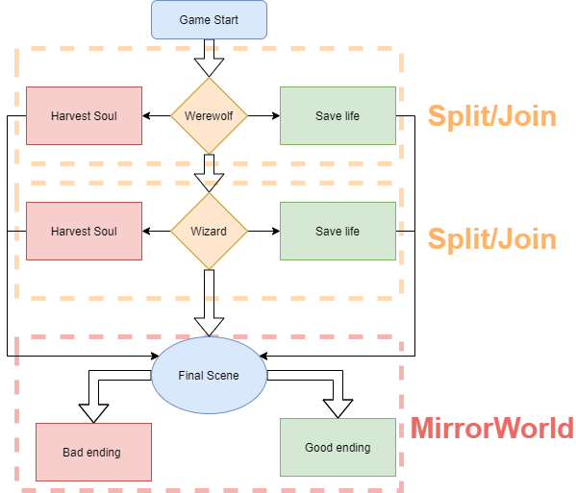

Figure : Use of different structures within the game

* **Type of choices**: we wanted to manifest agency by using the “**Deferred”** type of choice when the game records the choice and will see its impact further in the game.

## Cutscenes

We chose comic book style illustration for the main scenes to express the world mood. We added the final scenes to reward the player for completing the game.

The introduction shows the kingdom, the good king, and then shows that the kingdom is in peril - Jack puts on his hat; Verity is taken away; the evil mage is shown and finally the silhouette of the dragon stone is shown.

**Bad ending** - Verity is found dead by the mad king and her soul is trapped in a glass enclosure that is used to power the king’s plans. Jack is overthrown with greed as he has harvested many souls, and finally harvests Verity.

**Good ending** - Verity is found to be alive. She was being used to power the king’s plans, but she is weak and trapped. Jack frees her and it shows the clouds clearing up to reveal a clear sunny day. All looks good, and it then shows the village being rebuilt.

## Tone

The tone of the game is a choice of character - the potential of redemption, a second chance, a chance to change the fate of the kingdom.

## Environmental Storytelling

The previous fate of the world will be narrated with in-game architecture, props and from interacting with the townsfolk. In the intro of the game you learn about the past.

## Narrative Perspective

The game’s narrative perspective is impersonating Jack as if you were in the game.

## Dialogue

The characters in the game speak in an incoherent made-up language that is visualised by a series of speech bubbles with emojis to indicate to the player what the characters are talking about.

There is also a narrator who acts as Jack's thoughts and opinion, expressed in English and in between the levels.

## Background story

Originally, a thousand years ago, the small kingdom of **Poldoor** was shepherded under the righteous King **Percival Strendleton**; under his rule, the kingdom lived in a centuries long period of peace and prosperity.

**The Order of Mages** was once a powerful organisation of mages and sorcerers, led by the ancient wizard **Zador,** described as the 'wisest of all’, who later became a personal close friend of the Emperor as well as his advisor.

**The Tribulation of Fiends** was an important event orchestrated by a nefarious mage **Vendra**, once a banished member of The Order who later became a devoted follower of the young King Rorgoth to wreak havoc on the world. This event called upon the services of the Soul Hunters.

The **Soul Hunters** were an ancient line of demon hunters dedicated to hunting supernatural creatures that posed a threat towards the kingdom. Originally, they served under the King as protectors of the realm and were respected among the townsfolk.

Soul Hunters are tasked with lifting the souls of humans trapped within a cursed body. Upon judging the soul they have released from a cursed creature, they are presented with the choice to either harvest or save their soul. This will affect the soul hunter’s mind and how they are seen in the world as either being good or bad.

However, everything changed after the ascension of the Mad Monarch Rogoth; they have now become branded as heretics and practitioners of black magic and thus are treated with disdain and hatred.

After a tragic event known as The Great Persecution orchestrated by the Mad King, those considered to be wielders of magic were hunted down and executed. Of the very few members who managed to survive, they have now gone into hiding as they risk the executioner's block if seen.

## Synopsis

The story focuses on Jack Grayson, one of the last Soul Hunters. As a boy, he was raised and trained by his father Dustin in the ways of Soul Hunting. After completing his training, Jack began following in his footsteps, hunting supernatural creatures and lifting the curses of trapped souls.

However, during The Great Persecution Jack and his father were forced into hiding to escape execution from the Mad King. During one riot they discovered a young girl named Verity who had seemingly been abandoned - with no one else to care for her, the Grayson’s took her in and raised her.

Years later, Dustin is killed at the hands of Rorgoth The Mad King and entrusted his generations-old hat to his son and asked Jack to protect Verity. Jack never told Verity of his past as he wished to keep it a secret from her as he felt it would drive her away.

One night, their house is ransacked under the orders of the Mad King Rogoth, who captured Verity and left Jack for dead.

Jack embarks on a quest to save Verity.

Throughout the story, Jack will discover what kind of Soul Hunter he is, and how far he is willing to go to save the only family he has left.

The player’s actions determine how Verity will perceive Jack and what kind of Soul Hunter she will eventually become.

## Goal

Find and save your adopted family member, Verity, in any moral way the player chooses.

## Characters

### Protagonists

* **Jack Grayson -** The silent protagonist of the game. Son of Dustin and one of the last Soul Hunters in existence. Jack embarks on a journey to save Verity from the Mad King and avenge his father’s death. This adventure will ask the question - what kind of person is Jack and how far is he willing to go?
* **Dustin Grayson -** A legendary experienced Soul Hunter and the father of Jack. He is a stoic, wise, but compassionate mentor who always places the needs of others before his own. In the beginning of the game, after a training session with his son, Dustin is killed at the hands of Rorgoth The Mad King.
* **Verity** - Sweet-natured, innocent and emotionally fragile little girl who acts as the emotional centrepiece of the game. Seemingly abandoned after a town riot, she was found and raised by the Graysons. She is later captured by Mad King Rorgoth for possessing extraordinary hidden abilities and imprisoned within his castle to take advantage of them. This sets Jack on a journey to rescue her.

### Antagonists

* **Howlgadesh -** The Werewolf originally known as **Sir Gallant** is the first antagonist encountered in the game.
* **Slyvia -** Evil sorceress, a devout follower of the mad king.
* **Rorgoth -** Aka ‘The Mad King’ is the main antagonist of the story. Corrupted by darkness.
* **Stone dragon -** Magic creature created by the mad king.

## Reason for story decisions

We decided to use the story of Jack on his quest to save Verity. This idea was originally used as a hook in order to bring the player into the game world and to engage the player in a quest to get them to interact with the game.

From this beginning we added Rorgoth as an antagonist as part of the hero’s journey formula as this is a great way to get the player invested in the story.

# Game mechanics

## Pick Ups

**Soul drops:** Throughout the levels we are going to have soul fragments - simple pick-ups that recharge a bit of the soul meter of the player - that will function as a reward on the critical part of the levels.

## Combat System

The player’s character’s sword is swung in the direction of the attack, which will cover a 180° arc for each side.

|  |  |
| --- | --- |
|  |  |
| Figure : Attack left and right with collision zones. | |

Similarly, while holding the ‘W’ key, the character’s head faces upwards, giving the player visual feedback. An attack at this point will release a 180° arc attack that covers the area above the character’s head.

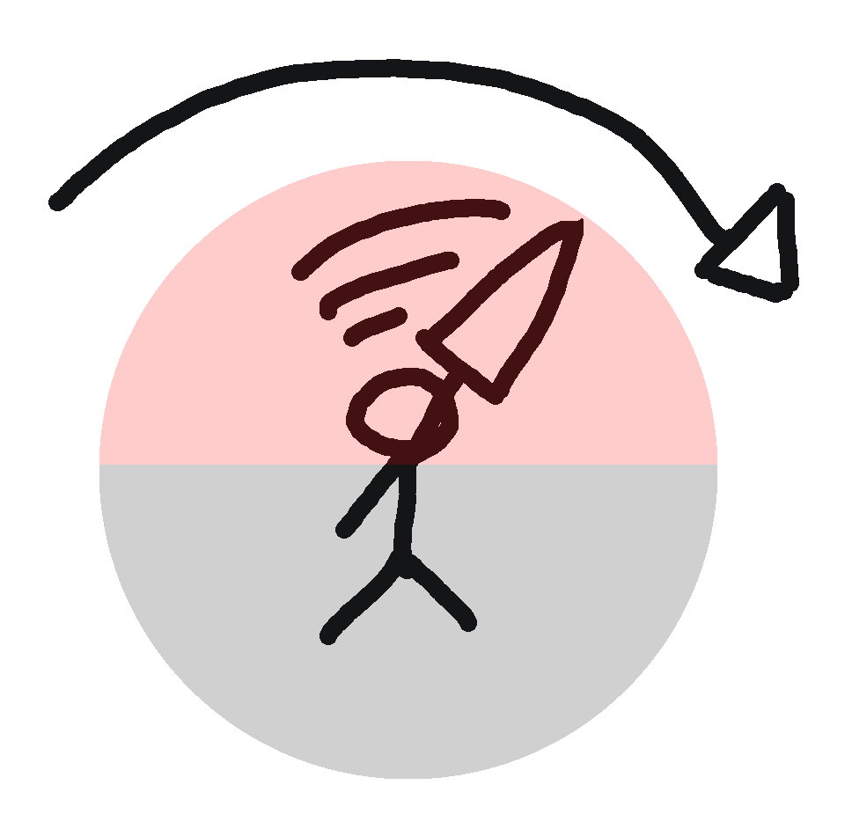

Figure : Attack up with collision zone.

This will allow the player to swing the sword attack in any direction and defend the area around the character.

### Soul meter

The soul meter is recharged when you hit an enemy - one hit will grant a portion of “soul energy”. Acting as the player’s health, it must be managed for survival.

### Collision feedback

When the player gets hit, we will have a dark particle effect scattering around with a boom sound and a slow-motion frame. This will create negative feedback and make the player feel the “pain” of the game character. There will be invincibility frames that make the character immune from damage for a short period of time to stop the character dying.

When the enemy gets hit by the player, we will have a light particle effect that simulates “souls” liberated from the corrupted body.

By separating the collision feedback colours, we can have a better visual feedback of who gets hit and link this with the narrative as the protagonist represents the light forces (that can get corrupted) against the enemies which are dark ones (that can get liberated).

### Morality Choice

The player can decide to either spare or harvest the mini boss’ life. If they choose ‘yes’, the character will gain new abilities.

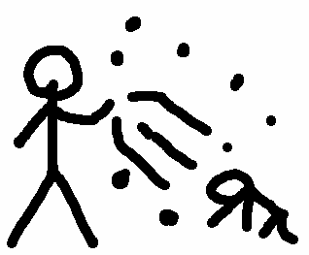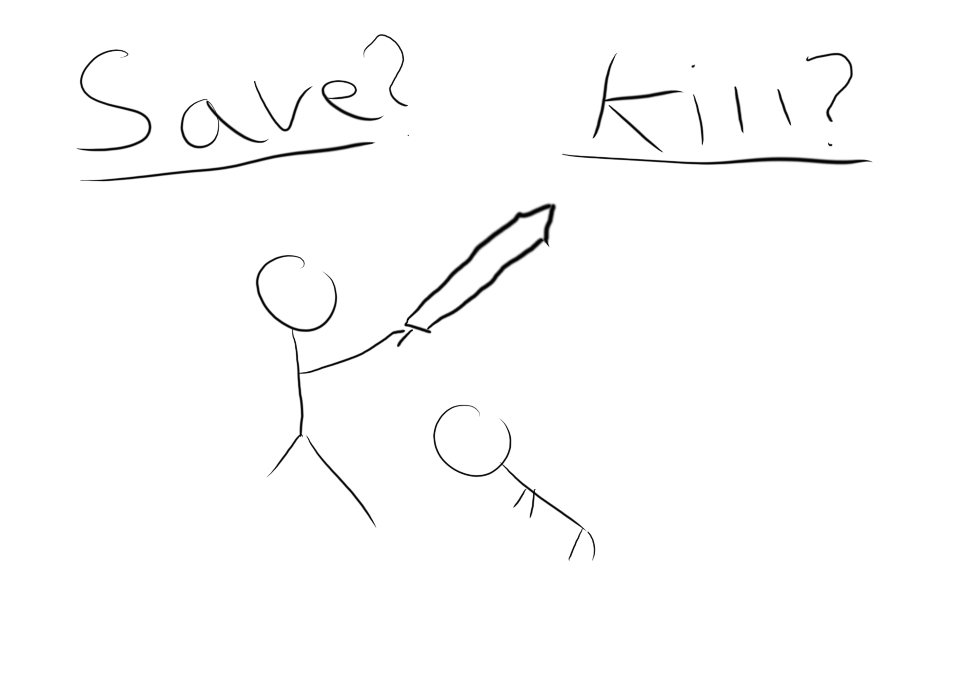

## Abilities

### Soul devour

The player can absorb extra abilities from powerful enemies.

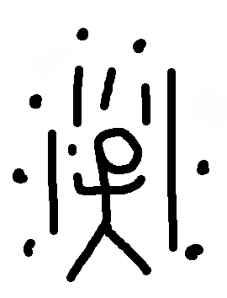

### Soul trade Ability

You can sacrifice some of the soul energy to get one hit point back. A button needs to be held and the player is obligated to stay in place for a few seconds, which adds an extra layer on the combat.

### Soul Dash Ability

You can dash in the direction that the character is facing. Limiting dash direction makes it easier to code, but also limits the bounds of the games. E.g. Flying enemies.

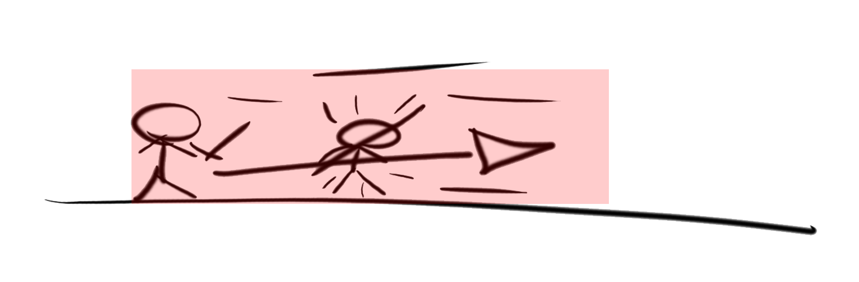

### Soul Blast ability

A projectile that is fired from the character in the direction that they are facing.

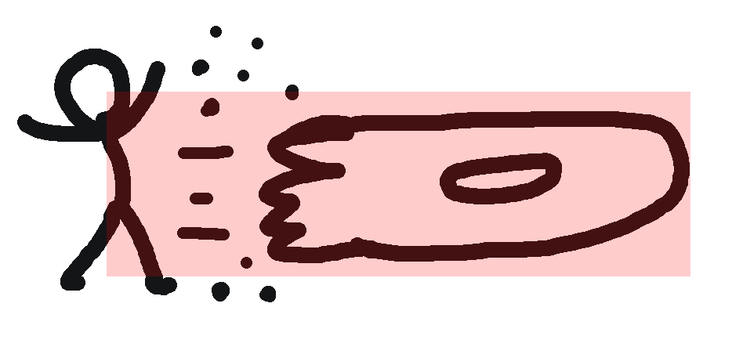

### Character movement

The character can move left, right and look up, as well as jump. We chose to include abilities the player would gain throughout the game to vary gameplay. It also shows character progression and story development. We chose these powerups as they are the abilities the enemies that are harvested use. This shows Jack obtaining power through harvesting the souls of his enemies and provides a strong backbone to our morality system.

## Morality system

The morality system creates a difficult choice for the player as they will be faced with different options. Depending on how the player views the situation, they will either decide to harvest the soul of their enemy, which will grant the character new abilities at the cost of the sanity of Jack (bad path), or they can save the soul of their enemy, which will not grant an ability, but is a good path.

The player choice in this game is more subtle than in other games - the game will not tell the player that the choice is good or bad, but will let the player decide based on the options. These are only found to be good or bad at the end of the story. We will express the choices in the intros to the levels with Jack contemplating his past decisions.

It will be possible to finish the game without any of the powers, but, if the player wants an easier playthrough, they can opt to harvest the souls of the mini-bosses - all the abilities will be explained to the player and used by the mini-bosses.

We also took advantage of a Fullerton’s Formal Element(*) called dilemma i.e. you have to sacrifice a character's life in exchange of power. This creates an internal conflict in the player, which impacts their choice and its effects as it gives an emotional value to it.

The implementation of this morality system was our principal philosophy behind our design of the game. This mechanic was the basis to gaining abilities as well as the game’s difficulty - the difficulty being changed based on how the player chooses to play the game is an idea we have not seen done much in the games industry.

## Game Length

We wanted to make an average size game from around ten-twenty minutes gameplay with two levels, one boss level and one tutorial level.

We want our player to feel immersed within the game, but we did not want it to take too long to complete since it only really contains three main levels.

There is also a re-playability aspect to the game - by using the morality system, the game can be played in two different ways and achieve two different endings.

# Gameplay

Morterality is a platform action-adventure game based on harvesting souls from the mini bosses and gaining their abilities. These abilities grant new gameplay mechanics, such as dashing. The main gameplay loop will include attacking in the direction the character is facing (tri-directional movement, left, right, up) to deal with an incoming variety of enemies. There will be a soul meter which is used as a mana bar. This can be used for abilities you have gained as well as heal the character. There will be bosses that vary gameplay at the end of the level. The levels will get progressively harder, culminating with the final boss of the game being a stone dragon.

## Doors

There will be one key placed per level, which will need to be collected to grant access to the Z axis (a unique element of our game). The Z axis is needed to pass the level as the boss for the level is locked behind a door.

## Controls

### Keyboard Controls

WASD for movement options, space to jump, J and L to use the abilities, I to interact and K to attack.

We used this approach to make the use as natural as possible - one hand is required for each section of the keyboard separating the moves and the actions, with the jumping button in the middle being reachable by both hands. However, because of the nature of the game, the best way to play would be with an Xbox Controller.

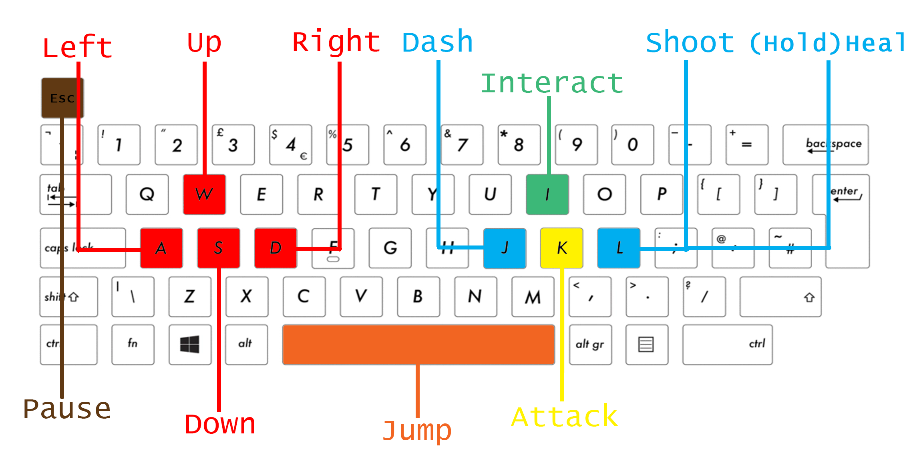

Figure : Keyboard layout showing functions

### Joypad Controls

The joypad is the most comfortable way to play this game, we set the commands based on conventions established of past games in fact we have used classical buttons for some of the controls used often for similar games such as (A) for jump and (X) to attack. The reason that we put (RB) for dash is because it is more likely to be used in combat whereas (B), the shoot button the player would usually take some distance before using it which will suit more while using (X) and (A) to move and jump.

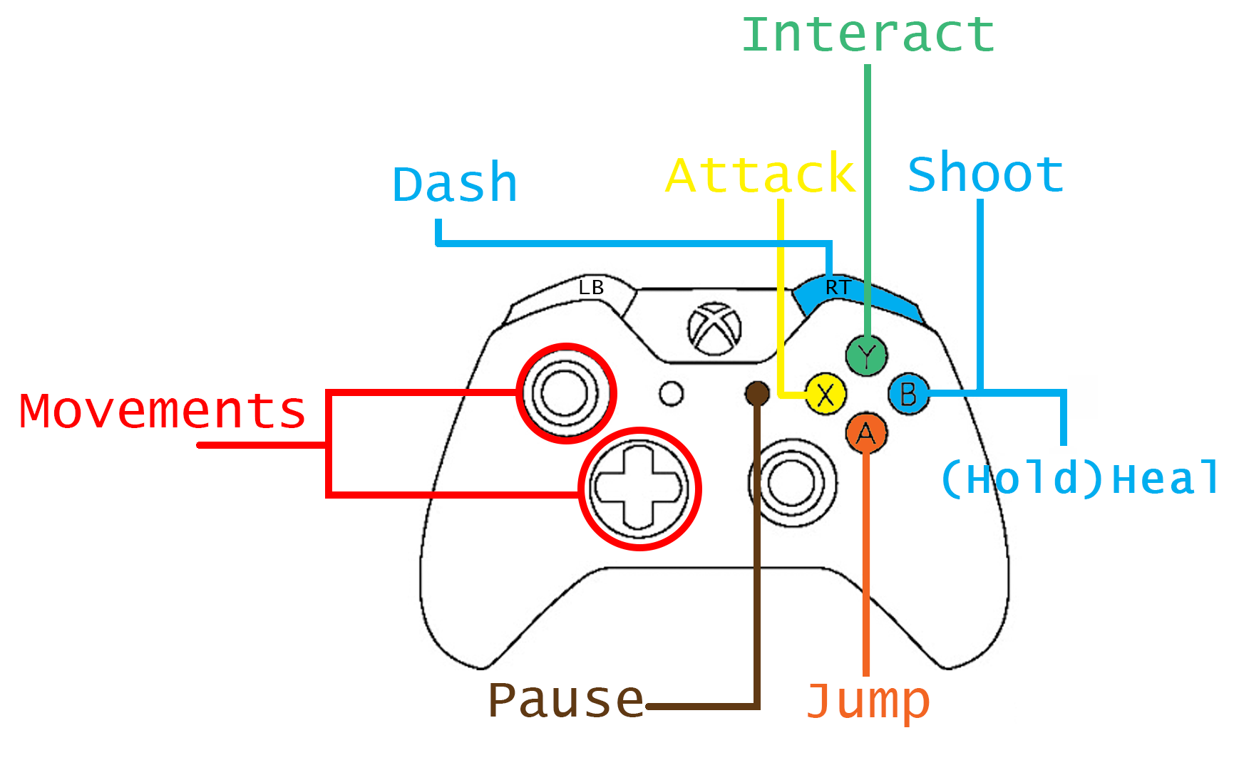

Figure : Joypad controls

### Enemies

* **Walker:** This enemy will walk back and forth ignoring the player - the most common and simple enemy.

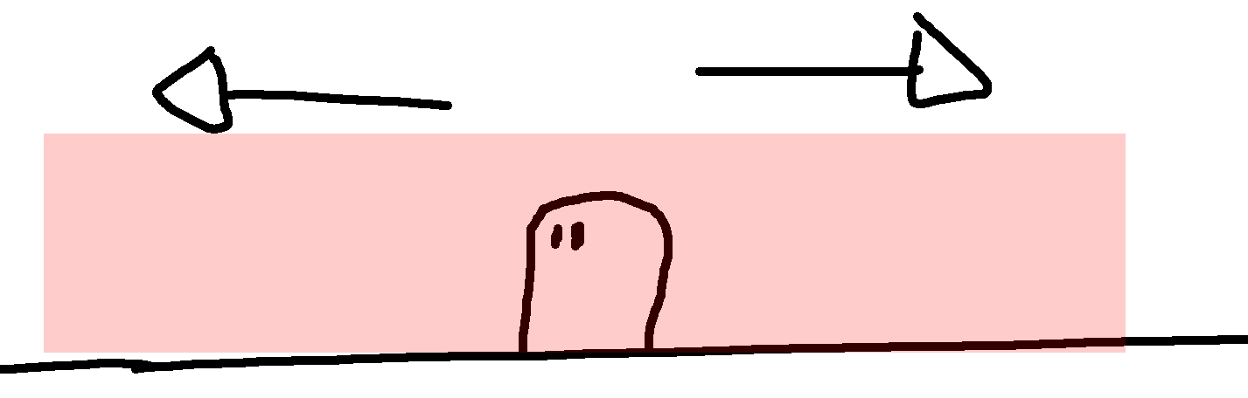

* **Flyer:** This enemy will fly around bouncing off the walls ignoring the player.

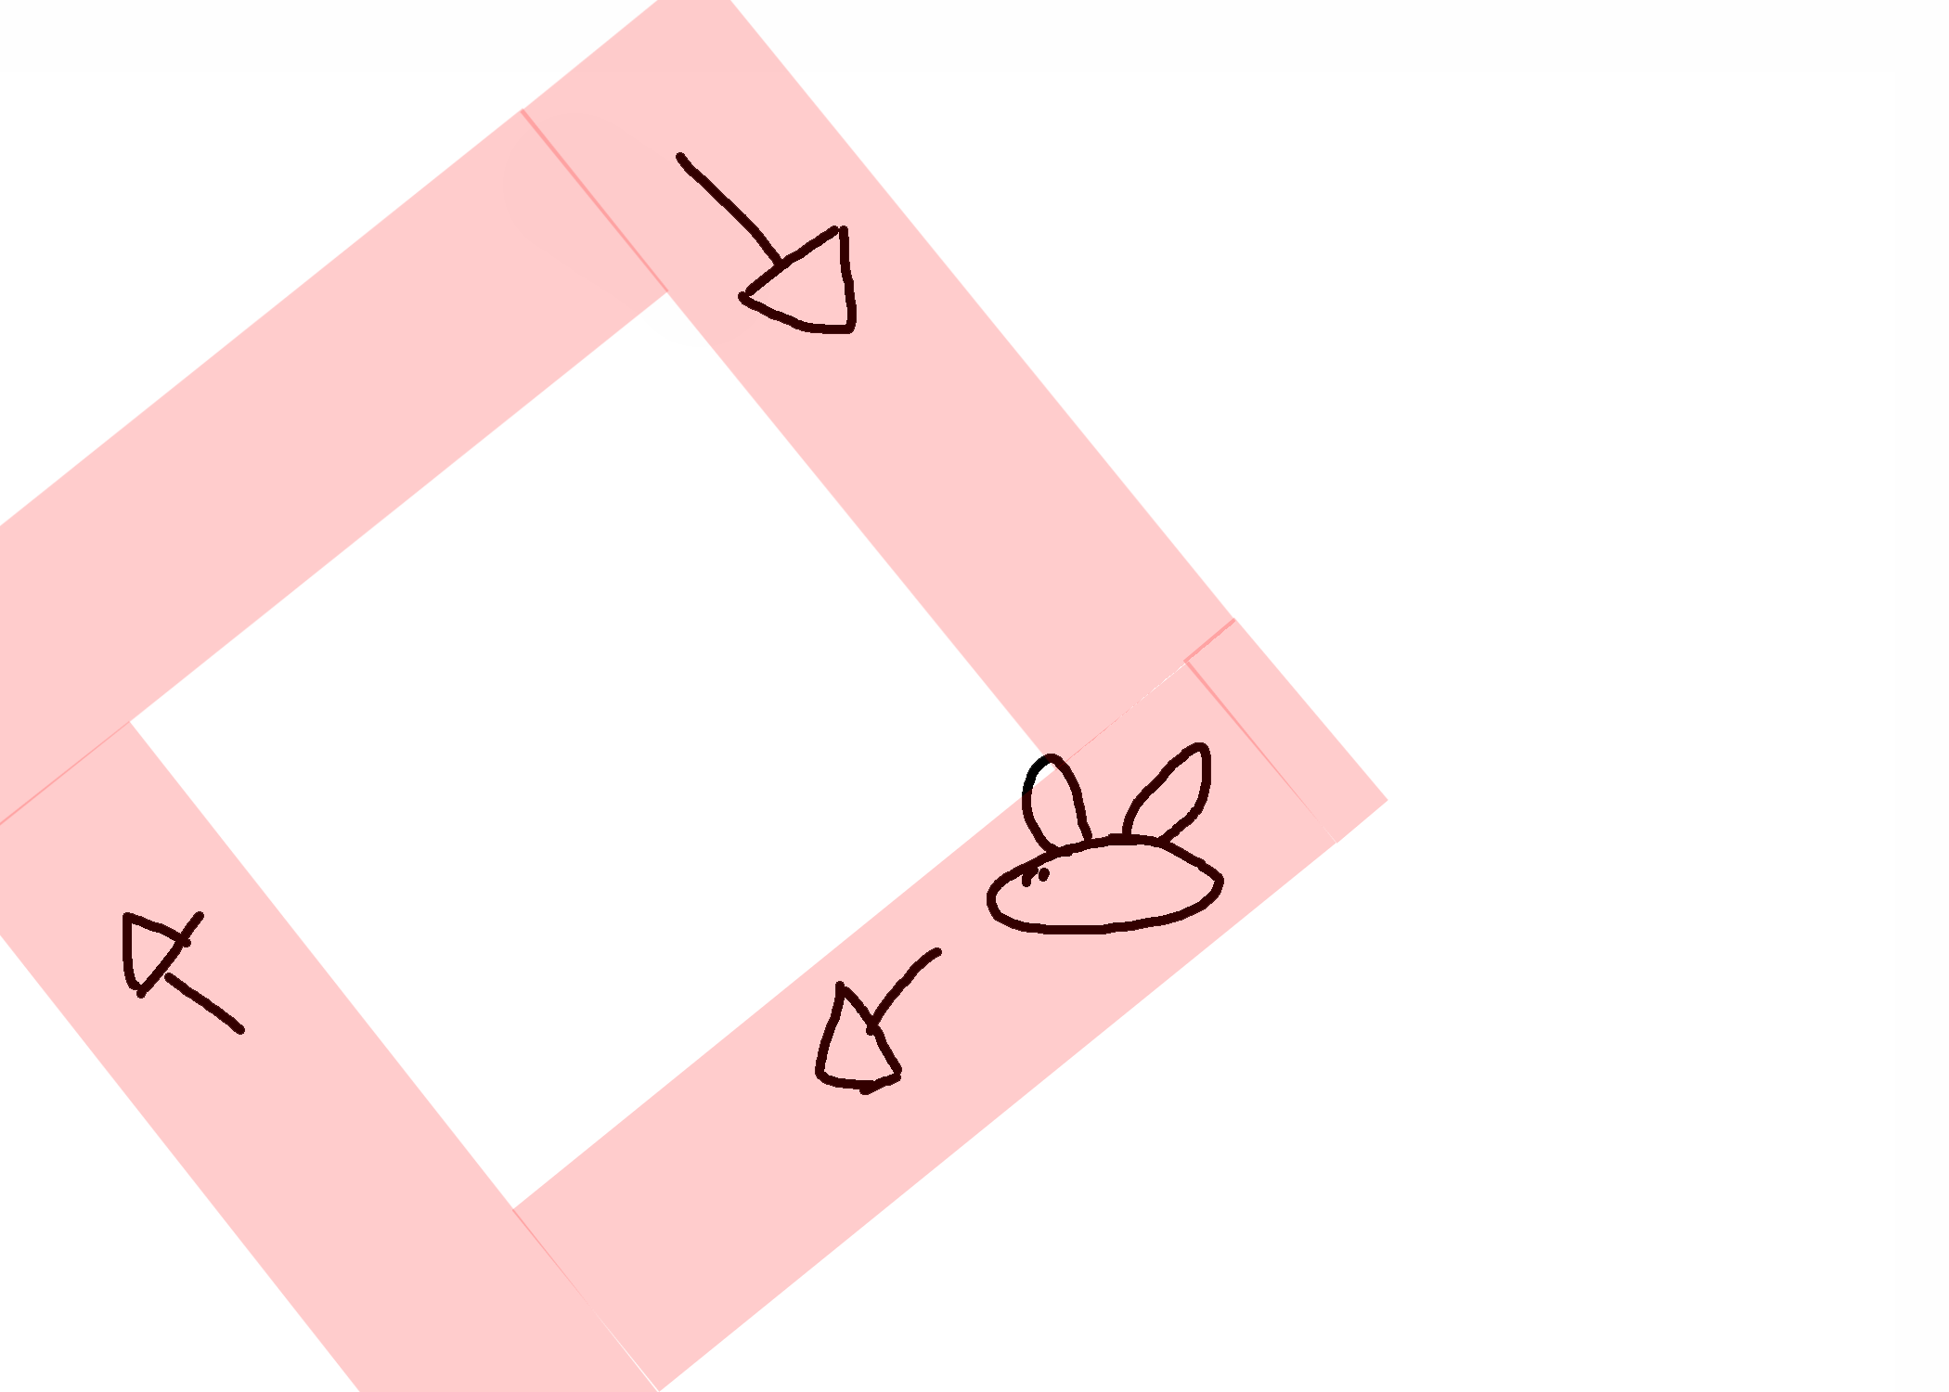

* **Jumper:** This enemy also waits for the player to be around - it will start to jump over the player. The blue circle is the trigger.

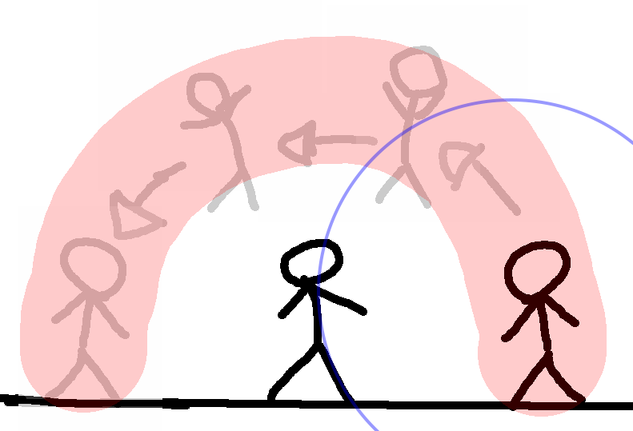

* **Charger:** This enemy will wait until the player is in a certain range, then it will attack with a simple dash toward the enemy.

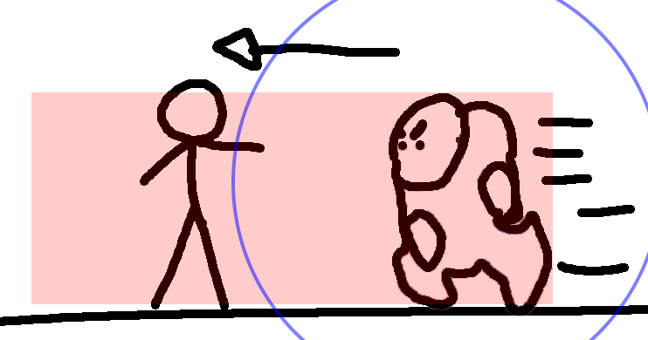

* **Shooter:** This enemy will only get triggered once the player is in a certain range. Then it will shoot a simple projectile.

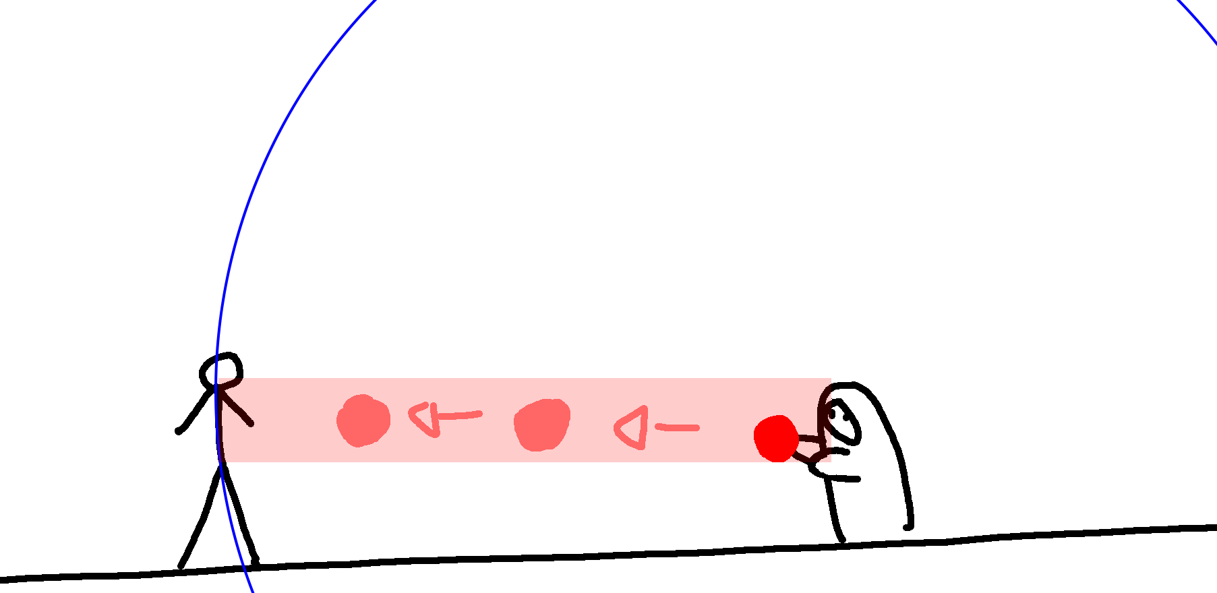

* **Defender:** This enemy will have a shield that will be raised in set times. Sometimes it can attack with his shield too. This enemy is quite slow, and after a few seconds of wielding its shield it will get tired and lower it down.

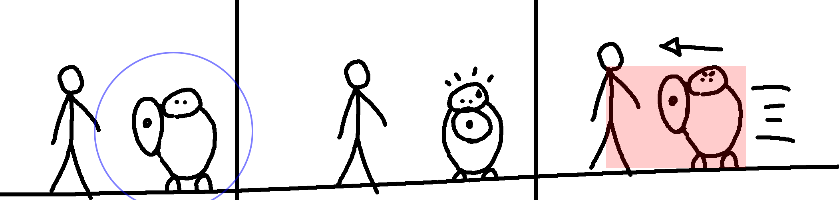

## Game theory applied

We want the player to feel the sense of growth and power – this is shown in the story in which our avatar, Jack, is compared with his father’s power at the start of the game – the player controls Jack, who has no abilities whatsoever. Later, Jack will have the ability to gain new powers from soul-bounding with defeated bosses. This will show character growth both by gaining a new ability but also how Jack’s outlook on the game changes throughout the decisions the player makes.

The aim of the game is to trigger satisfaction after completing a modular challenge i.e. a level. To do this we give positive feedback.

To achieve the “fun factor” we have designed the levels to provide the balance between player ability and game difficulty. Our approached has been informed by Mihaly Csikszentmihalyi theories, especially, the condition named “flow”.

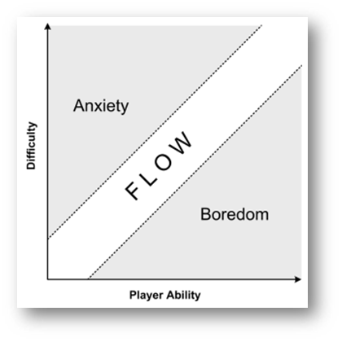

Figure : Mihaly Csikszentmihalyi' flow theory

## Level Navigation

We set out to achieve the feeling of freedom when navigating the levels without making the gameplay unjust. The character moves are therefore precise with very little inertia so the player’s acceleration does not affect the combat too much.

### Z axis:

To take advantage of the 2.5-dimension camera, we have given the player more mobility. This was achieved by building our levels with an extra layer of dimension that the player can use to go inward and outwards through the Z axis – these “entries” will be clearly shown to the player in the form of doors, bridges and paths.

The player will not be able to return from level 2 to level 1 or from the boss level to level 2. If the player wants to go back a level, they will have to replay them.

## Levels Design

The Prologue introduces players to the story and abilities, which will act as a tutorial, followed by two base levels and a final boss level which ends with a final wrap-up of the players morality choices and their outcomes.

The levels will be consistent with the theme of the game and developed in a way that the player feels like they are progressing through the story. For example, for one of the maps the skybox will be an evening theme skybox - in the first level the sun is coming down and it is becoming dark, as the player progresses to the second level, the skybox will be a night sky, which makes the player feel like they are progressing and will give the notion of time passing.

We wanted to give meaningful play to our game in a variety of ways, one of the ways we found for the player to make a meaningful choice was our morality system.

For most of the game we have descriptive meaningful play, defined by the close connection between the in-game **action** and its system **outcome** in the gameplay. Players can express urgency throughout fast paced actions - depending on the player’s choices, their game will be harder or easier. There will also be extra areas available within the levels where players will be able to explore freely and defeat some more enemies.

Each decision for the design of the level was taken with the intent of making the game challenging for the player, but also very engaging. For example, another choice that the player can make (which will directly affect how they react to certain situations, such as traps or warnings of different types of monsters), are the “NPCs”. There will be multiple NPCs around the map that the player can interact with to have a better understanding of what is ahead in that direction. For example, there will be traps and mini-bosses; before these events, we will place an NPC to give a hint to the player that something dodgy is about to happen or a strong foe is just ahead.

Making decisions when to jump to avoid attacks or when to use an ability within our game is key to success; the player needs to make these choices that initially might not seem significant, but can quickly result in a player not having a lot of health and dying. To survive the player needs to make decisions on how to approach each enemy and who to avoid or even kill first.

Our game is heavily based on storytelling, with the levels and environment helping to set the scene and tell the story of our game. To avoid a lot of text-based conversations within our game we are using emojis.

### Tutorial Section

#### Help aids

The aim of the tutorial is to ease the player into the style of gameplay. The player will be asked to make a series of different small actions to show the different moves and attacks which can be used within our game.

Our idea was inspired by “CupHead”, a very famous platformer who excelled at showing players how to play the game, or rather how to prepare for a variety of situations within the gameplay.

#### Save the player from the player

If the player is not able to progress through the obstacle course, the game will not allow them to progress through the tutorial level. This has been done to ensure that the player has mastered all the tactics and controls so that the subsequent playthrough is a better experience.

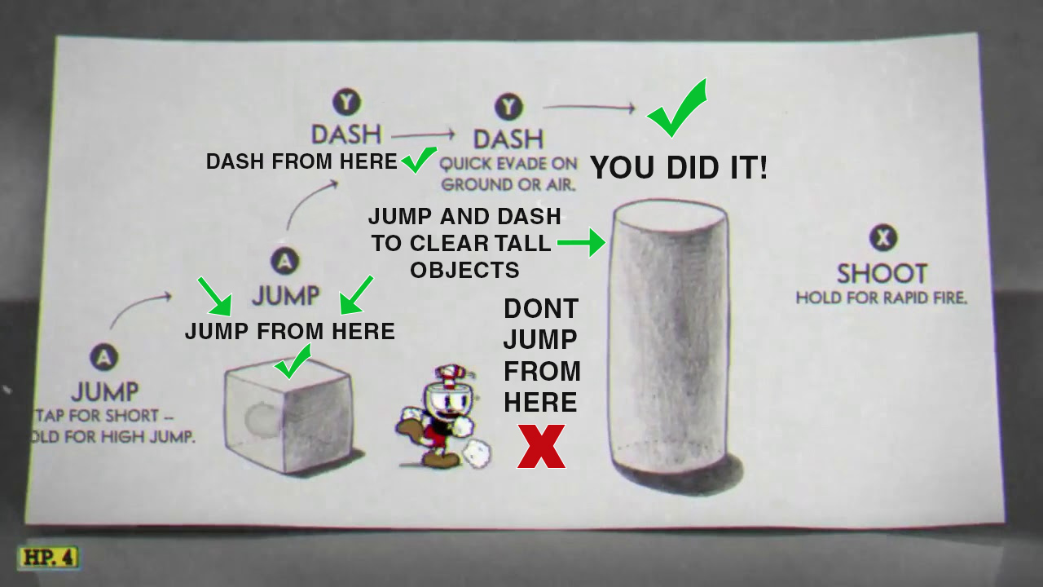

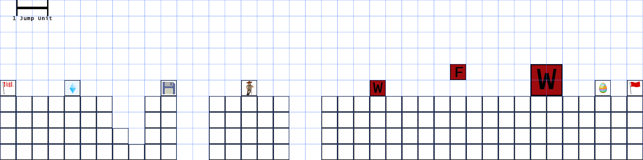

Figure : Tutorial

Our tutorial level is meant to teach the very basic mechanics and the concept of our game, it integrates the three most valuable mechanics – jumping, Interacting with villagers, and attacking enemies - all of which will be experienced by the player and learned with room for mistakes.

### Levels

The player will be presented with a variety of different enemies in the two levels and finally with a boss level. The level design for the first two levels will be inspired from games like “Castlevania – Aria of Sorrow” and “Shovel Knight”.

|  |  |
| --- | --- |
|  |  |
| Figure : Images from Castlevania and Shovel Knight | |

We decided that level design will be key in making sure that the player can progress within the game both with the power-ups and without.

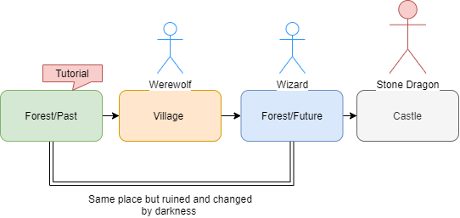

Figure : Level Navigation

#### Level 1

Level 1 is more player friendly and without too many complicated actions - simple jumps, a small number of traps around the map or defeating enemies that are alone. This will enable the player to easily understand and adapt to the game concepts.

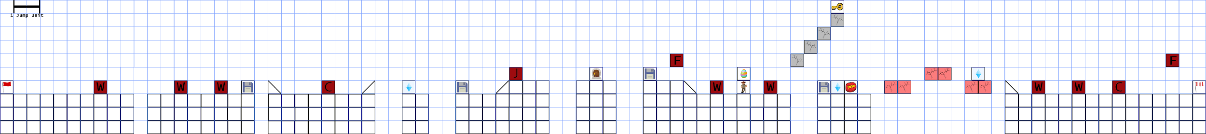

Figure : Level 1

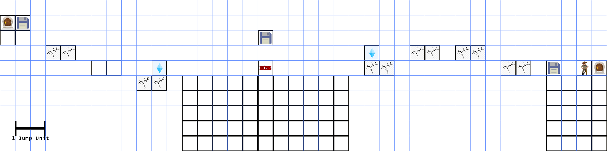

Figure : Level 1 Z-axis

Level one has very basic features, such as some floating platforms, which make the player focus before jumping - if they miss the jump, they will end up dying.

This was made intentionally to make sure the player has a sense of progression and understands that in later levels the difficulty will increase.

The main gimmicks in the first level are jumping and falling platforms. It starts with easier jumps to ease the player into the mechanics as they are key to surpassing a lot of obstacles throughout the playthrough.

The difficulty within the jumps increases throughout the level; it starts off very forgiving for the player with some margin for error, but quickly gets more and more difficult to create the perfect balance between learning and difficulty.

The falling platforms are designed to make the player react fast and pick up this skill of reacting faster to obstacles that are put in their way. By developing this skill, the player will improve their chances of having an easier playthrough of the game. Again, we ease the player into this new mechanic by having some margin for error.

**Level 1- Mini boss- Werewolf:** Ability to dash forward and deal damage as it passes through the player. The werewolf will have very exaggerated animations while preparing to release the ability; this will make it obvious to the player that the enemy is about to release a strong attack. The player will be able to avoid this ability by jumping above the enemy.

#### Level 2

The second level is more challenging with a variety of new obstacles and the reuse of the previous obstacles, but in a different manner and with increasing difficulty in both player’s choice and ability.

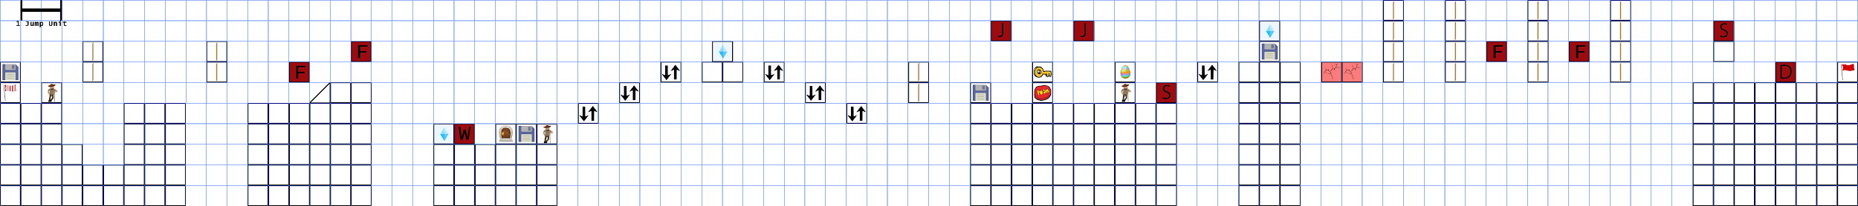

Figure : Level 2

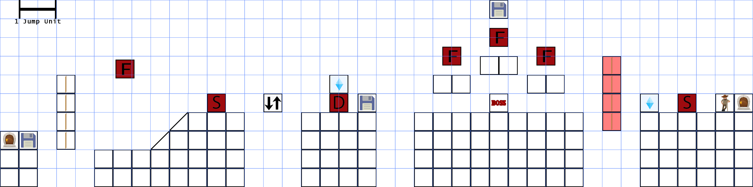

Figure : Level 2 Z-Axis

Level 2 introduces ropes to jump to platforms and moving platforms to create a higher level of difficulty (see figure 16). These two challenges are presented to the player in a variety of ways and difficulties. This difficulty increases as the level progresses and the player will see their understanding of the different obstacles being tested to the limit.

To create a perfect balance between the learning curve and the difficulty of the level, we will provide room for error in a safe space where the player will not be punished if they make a mistake.

**Level 2- Mini boss - Wizard:** Ability to throw a projectile that will damage the player when it collides with them. It will also do a very exaggerated animation before using the attack, allowing the player to react and avoid the projectiles. The player can dodge this ability by jumping and sending some of them back if they hit them with the sword.

#### Level 3 – Final Boss

For this level the player will face a big monstrous boss, placed in the middle of a circular platform that the player can go around.

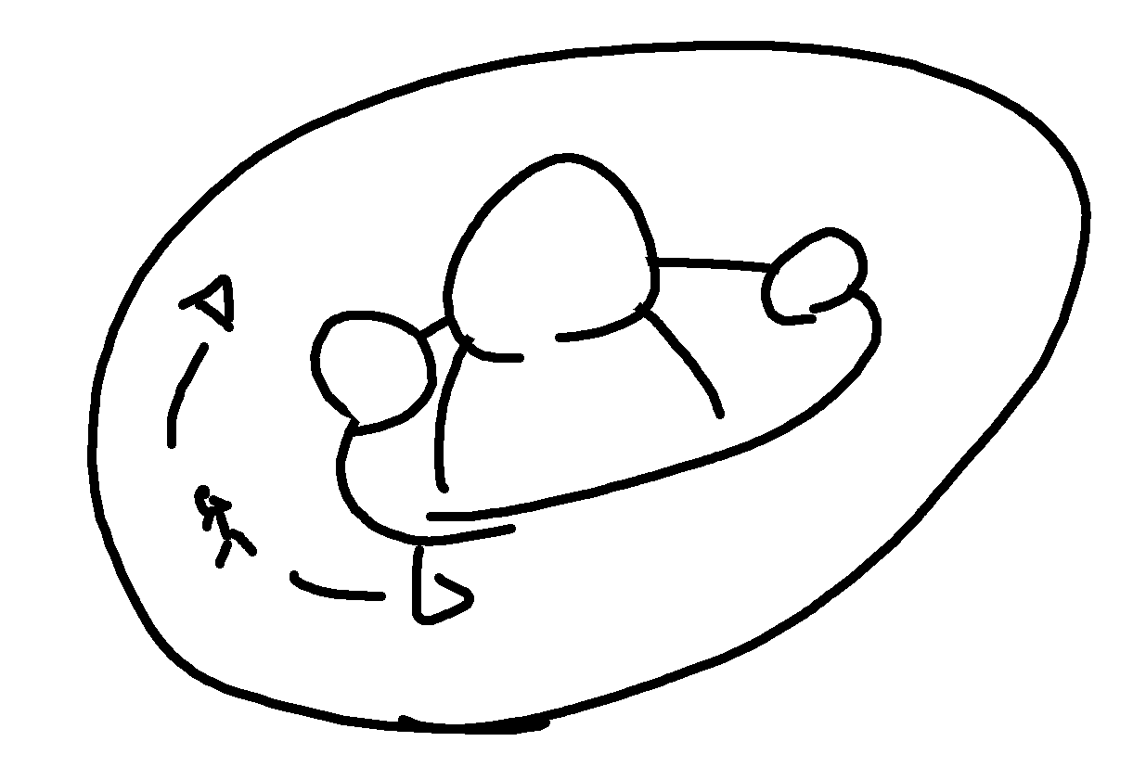

Figure : Boss level Map structure

The objective of the level is to take all the boss’ life out, by hitting them in key areas:

* The head, which is harder to reach but also deals a lot of damage if hit.
* The fists that are placed on the middle of the screen and are easier to reach, but they move around and can damage the player.
* The “tail” of the enemy that is on its back - the player can use the circular platform to go around and hit it, which causes less damage and is the easiest to reach.

|  |  |
| --- | --- |
|  |  |
| Figure : Collision areas in red (front and back), which the player has to hit to damage the boss. | |

For this level we decided to divide the final fight into three main phases. We created an incremental difficulty as we do not want the player to get overwhelmed. Each phase will have one key aspect represented by the boss attacks and its patterns:

* **Phase 1** **- Normal attacks:** the boss will try to hit the player with only physical attacks and will move slowly with a cool down that will indicate when the player can attack.

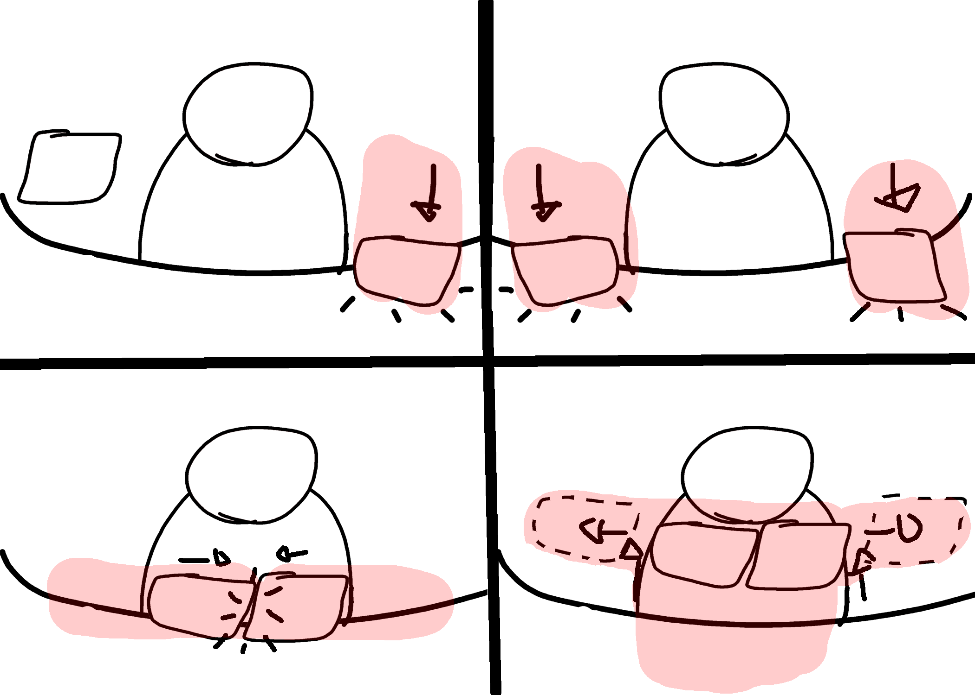

Figure : Hazardous zones shown in red during animation

* **Phase 2** **– Projectile attacks:** some floating platforms will appear to help the player move around. In addition to the normal attack, the enemy will shoot projectiles from the head section; some of the projectiles can be sent back if hit by the player. Those attacks will be combined with the previous ones.

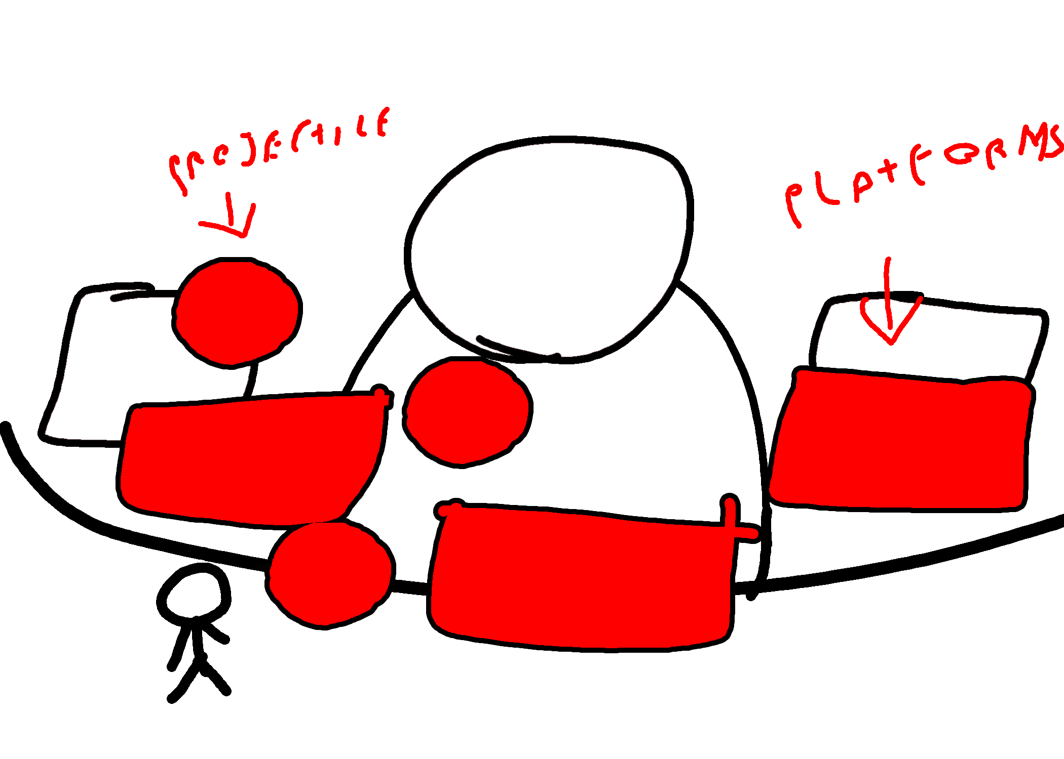 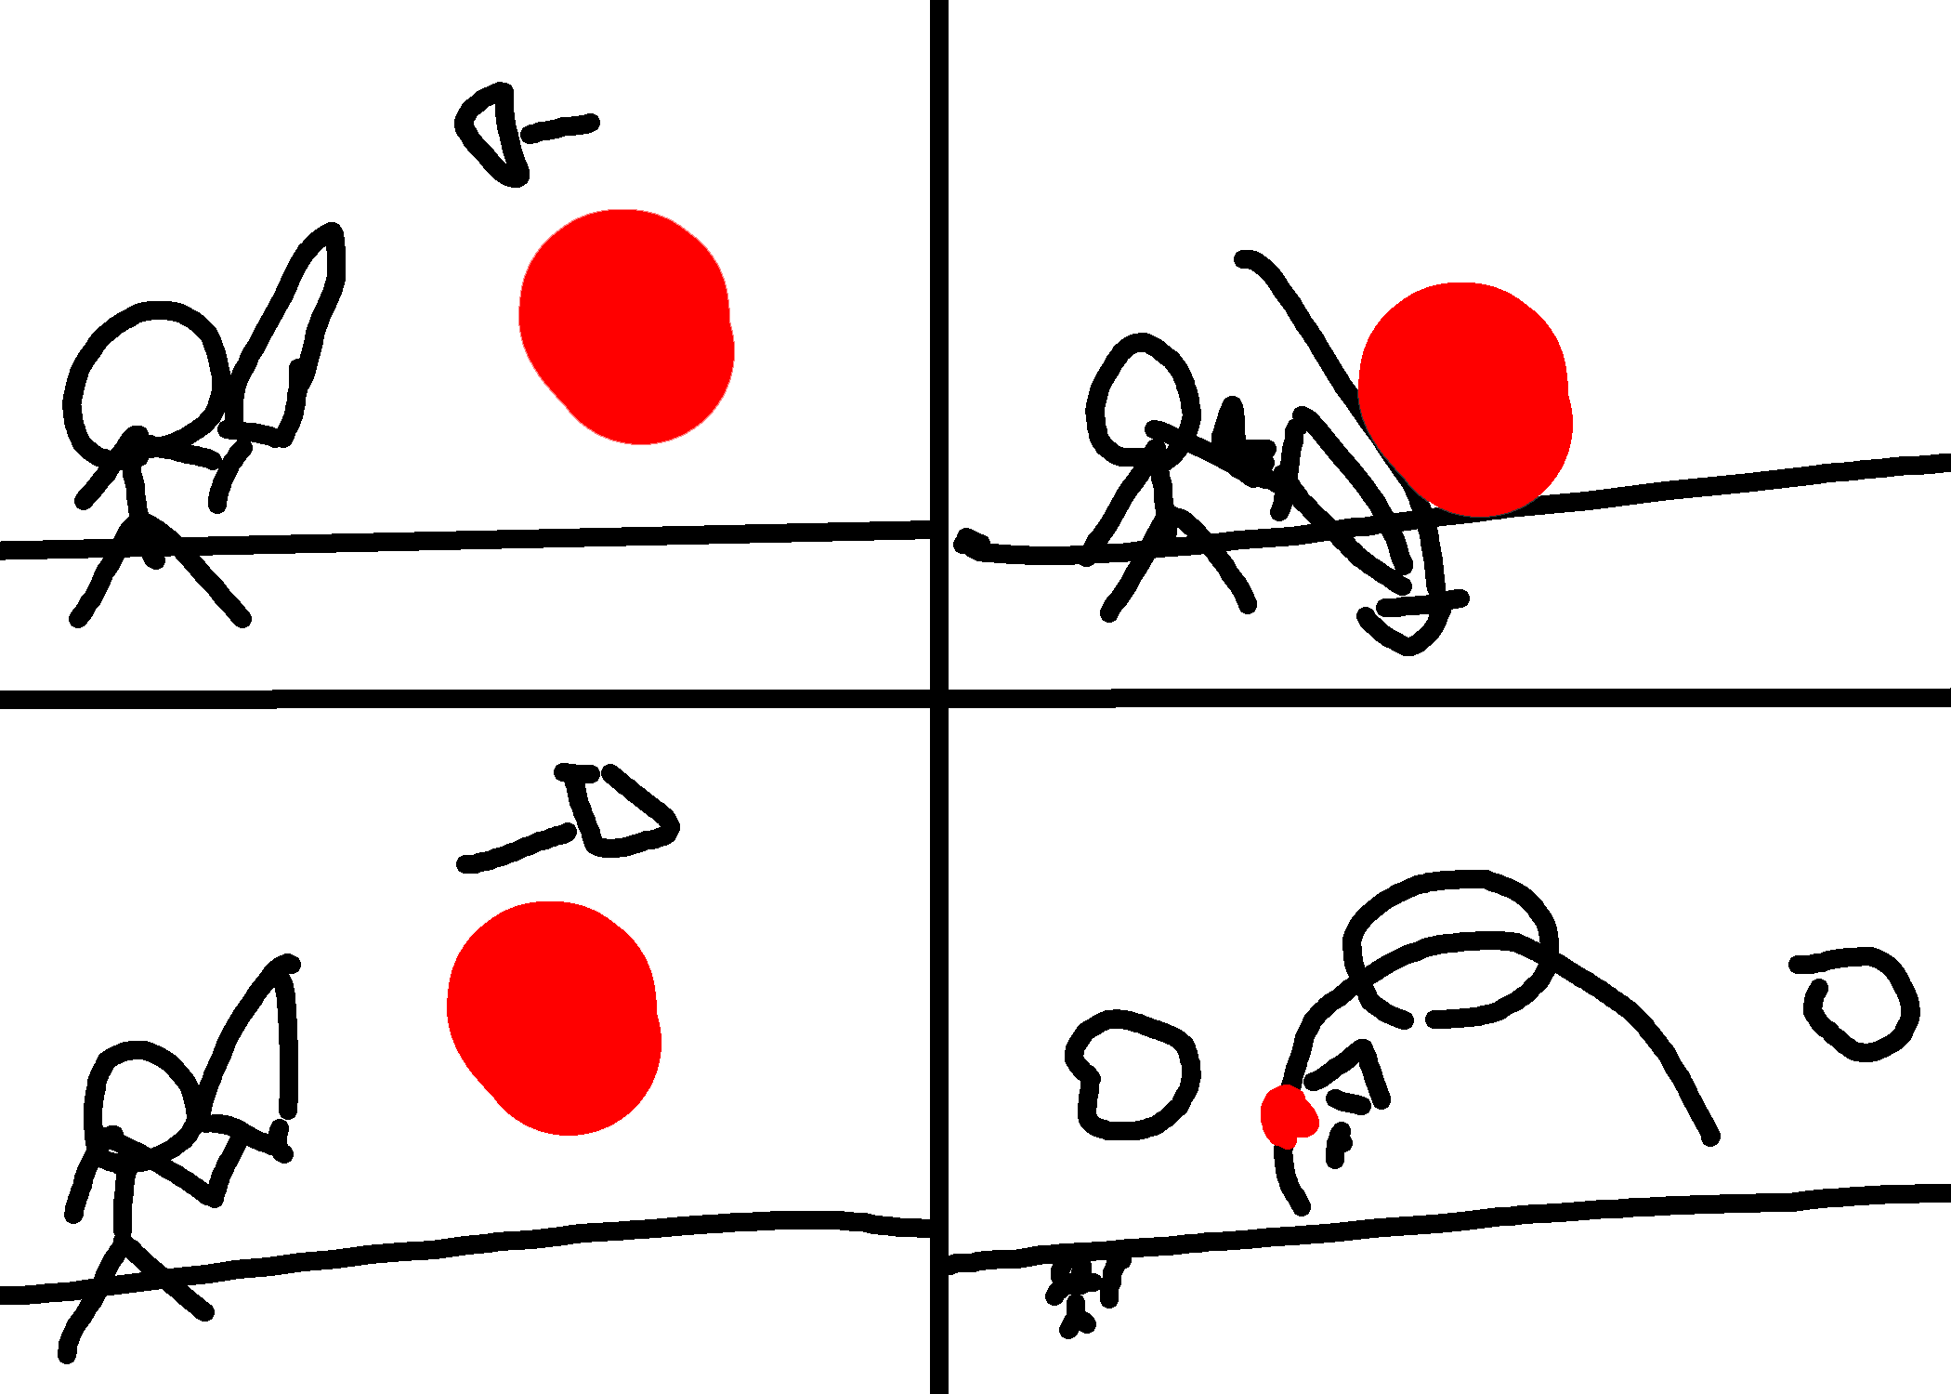

Figure : Phase 2 representation Figure : Bouncing of the projectile mechanic

* **Phase 3** **- Charged attacks:** For this the attack there will be a charging animation and a beam of light coming towards the player in the form of a column. This attack will be alternating with the prior ones.

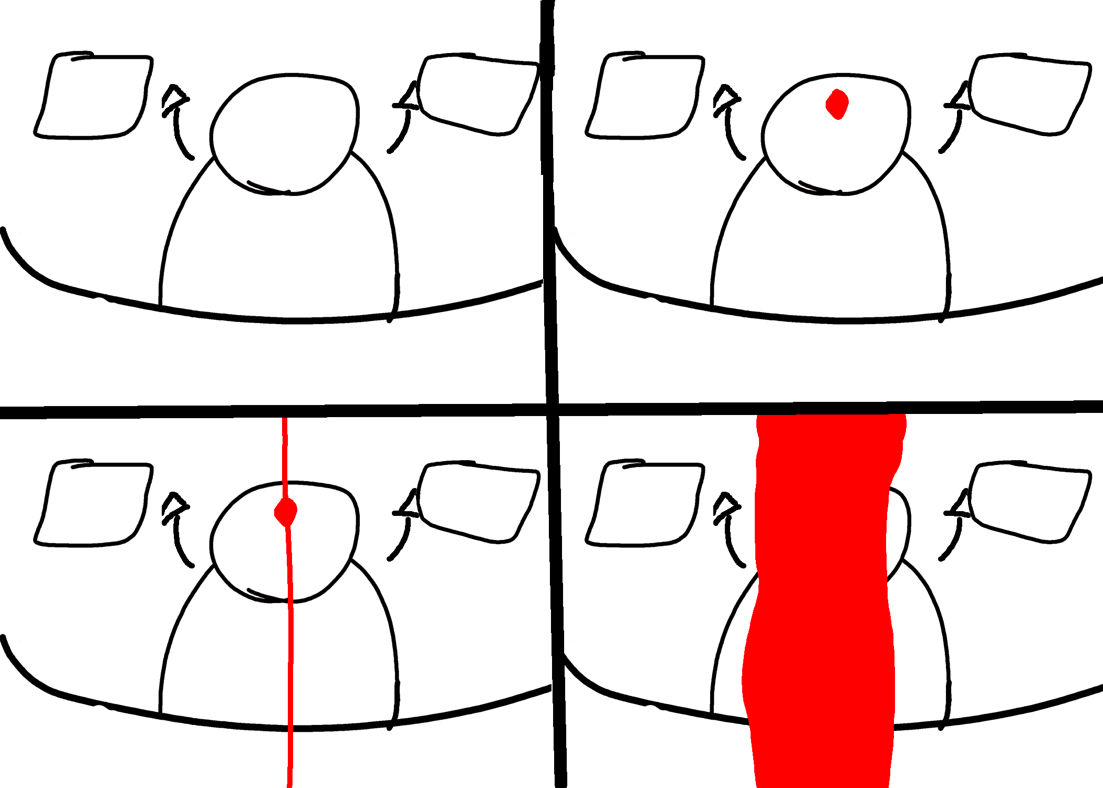

Figure : Charging and releasing the damaging beam

## Objective

The objective is to finish the levels by defeating the mini-bosses until the player reaches the final boss and defeats him, after which the player will be presented with either a good or bad ending.

## Losing conditions

When the player’s hit points reaches 0 the game is over. The character will be sent to the closest checkpoint.

# Visuals

## Symbolism

We want to deliver messages through symbolism; for example, we have achieved this in the game title by splitting the name into Morte (coming from mortality) and Rality (coming from morality). We emphasised this by using contrasting fonts and colour - the perfect balance between life and death.

We then added the sun and the moon to symbolise the day to night cycle in the game and the fact that the game gets darker.

In addition, we have the balance scale to emphasis the neutrality of the choices that are made in the game.

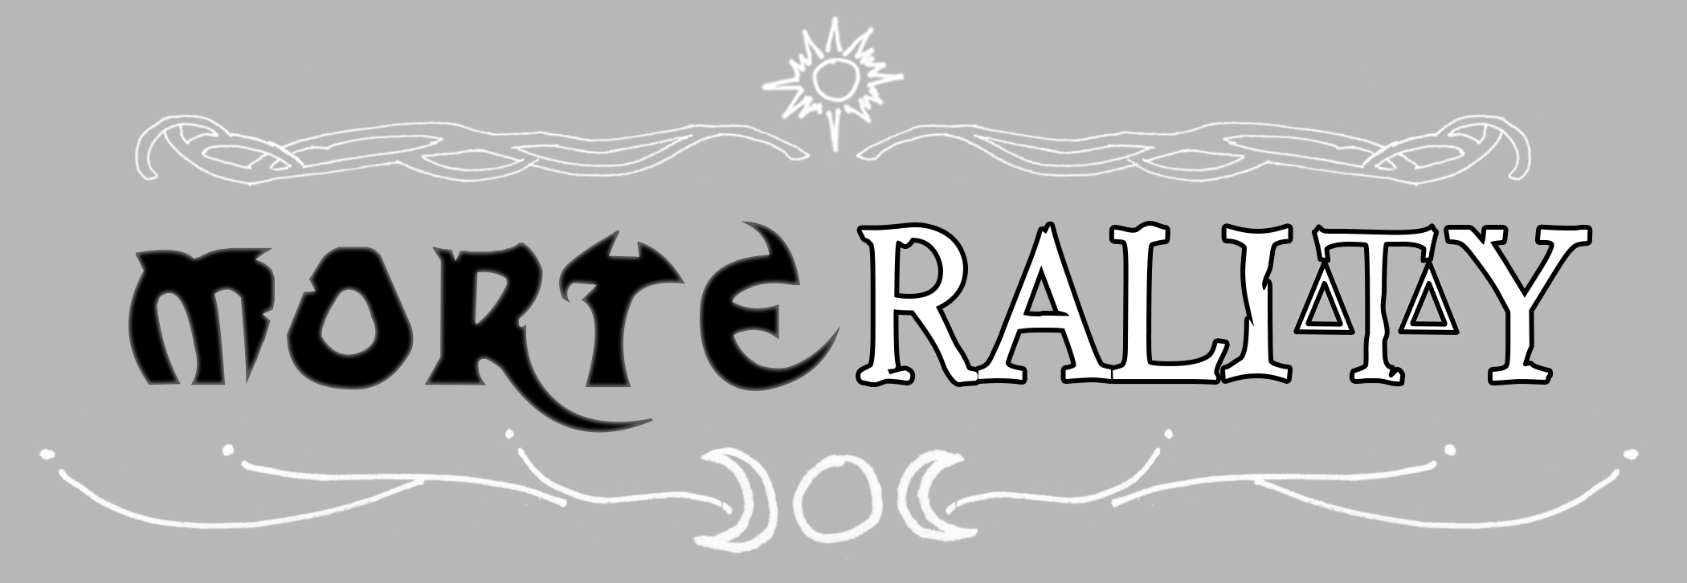

Figure : The game's title reflects its content and messages

## Character design

We used the chibi style (ちび or チビ - Japanese slang for someone or something short) for the design of the characters, which is an art style often used in mangas to exaggerate characters' features and reactions. We wanted to use this style in order to balance the dark and gloomy mood of the maps.

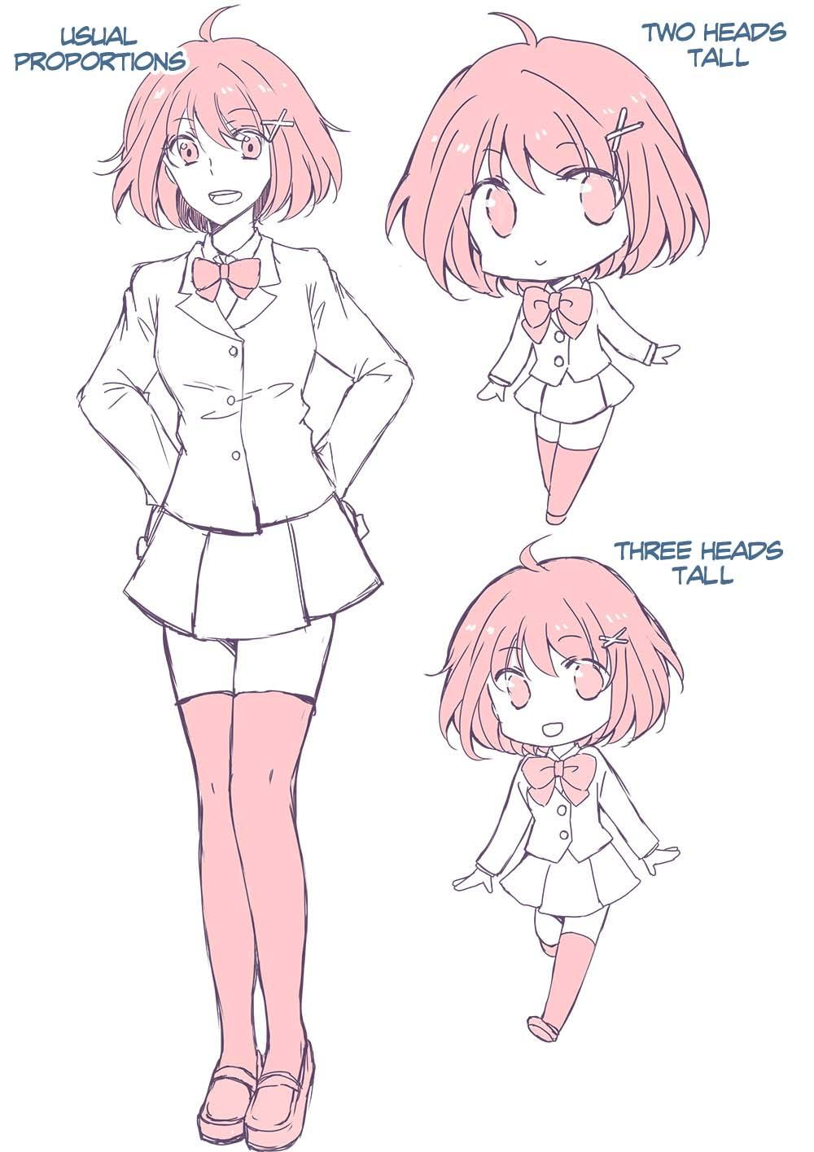

Figure : The chibi style used to design the characters in the game

### Characters

|  |  |  |
| --- | --- | --- |
|  |  |  |
| **Jack** | **Dustin** | **Verity** |

|  |  |
| --- | --- |
|  |  |
| **Howlgadesh** | **Slyvia** |

### Enemies

|  |  |
| --- | --- |
|  |  |
| **Jumper** | **Charger** |

|  |  |  |
| --- | --- | --- |
|  |  |  |
| **Flyer** | **Shooter** | **Defender** |

We chose these visuals for enemies because they are quite different from each other, which will avoid ambiguity in the different enemy types. This means that the player will be able to distinguish between them and easily tell what their ability is.

## Graphics

### Visual style

We have used a stylised 2.5D, i.e. 2D characters contrasting against the 3D environment, including the assets in the foreground and the background.

We chose this 2.5D visual style because we are skilled at hard surface modelling, as well as 2D character vector art; having both 3D and 2D elements means that we will be able to produce our highest quality work for both 2D and 3D.

## Lighting

The overall lighting of the game will change from slightly brighter, warm scenes, to very dark scenes, as mentioned before. Starting with the prologue, it is the brightest level in the game to contrast well with every level after. Therefore, the directional light within the scene will be a high intensity yellow/white. Then, using additional objects within the scene, we will create the “light rays” effect scene in traditional forests during the morning hours, see figure below. No other lights will be necessary for “lighting” the rest of the level, however; other point lights and spotlights can be used to highlight different points of interest during the tutorial.

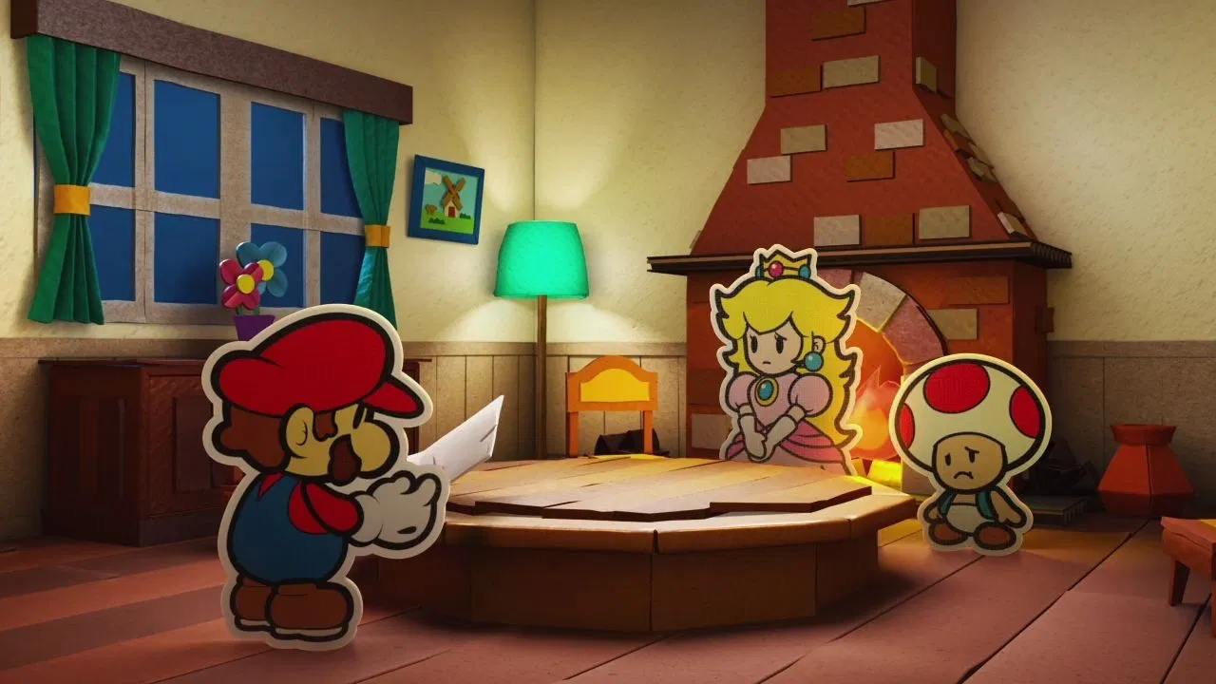 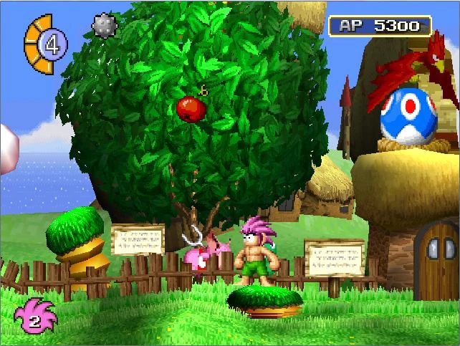

Figure Figure

## Colour and mood transition

In the environments of the gameplay we wanted to enforce the emotional transition present in the narrative. As the player discovers more and more, the story gets darker, which is reflected in the mood and the gameplay - we wanted to take advantage of this by providing extra feedback in the actual environment.

As the player progresses throughout the gameplay, we have pushed the boundaries of storytelling through the levels by progressively going from day (Tutorial) to sunset (Level1) to night-time (Level2) to dark closed place (Boss level).



Figure : The spectrum of colours used to show the level progression

## Locations

**Forest in the past: daytime** - this will show how good the world used to be; a total nature immersion with warm colours where Jack and his father are going for a hunting session before the tragedy.

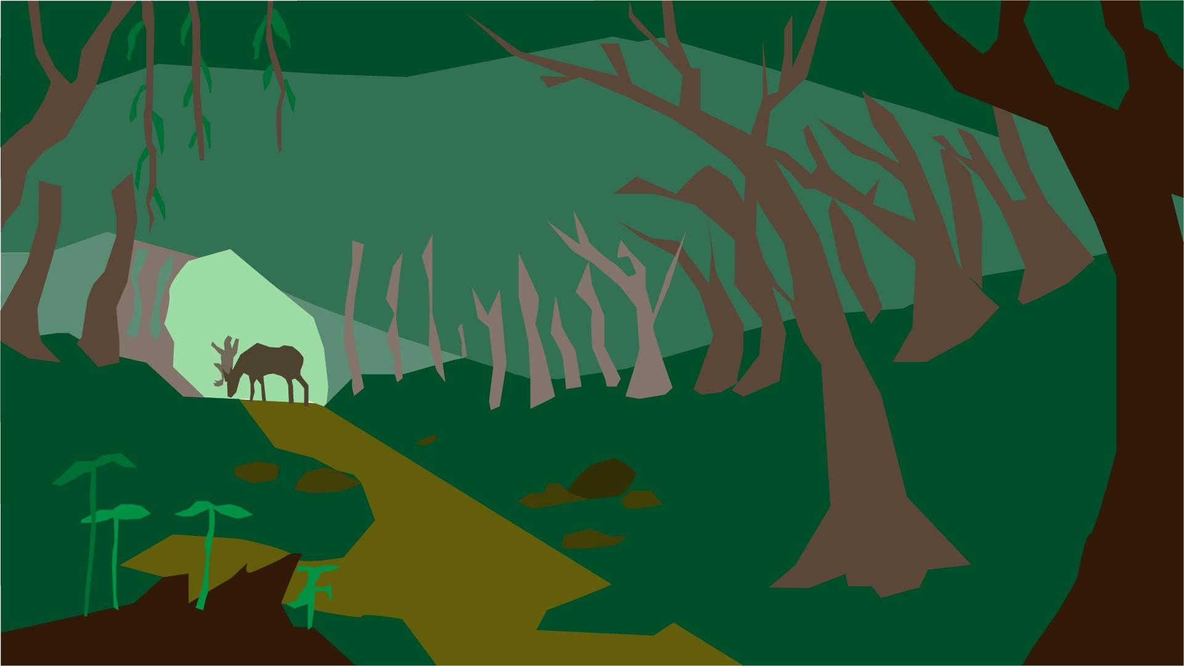

Figure : Concept art “Untouched forest”. Made by Antonino Frazzitta

**Village: Sunset** - time has passed and the village barely old up anymore, the “mad king” seems to have taken control over the kingdom. Here we can see the village under attack by the enemy forces. village on fire and war and murder is around the player. Transaction to warm to cold colours symbolizing the village left behind.

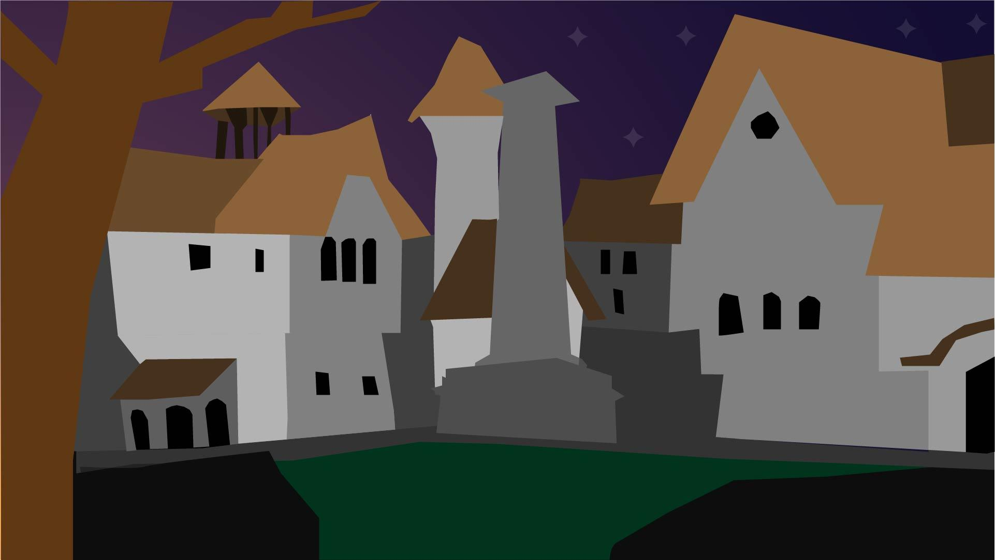

Figure : “Village” Concept Art, Made by Antonino Frazzitta

**Abandoned forest: Night-time** - a dark and gloomy environment, cold colour palette, complete opposite of how it used to be in the better days.

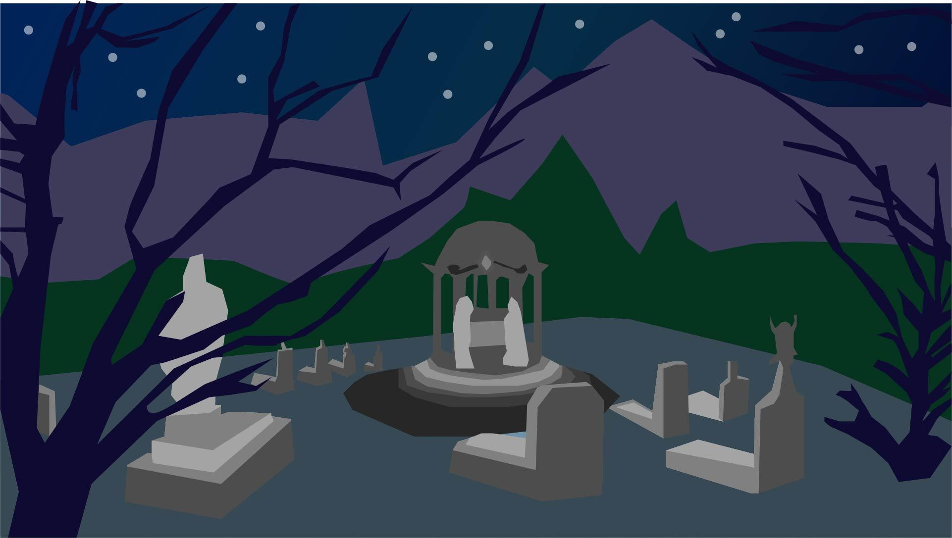

Figure : “Dark Forest” Concept Art, Made by Antonino Frazzitta

**Mad king castle: Indoors** - an extremely dark environment; with a one-to-one epic fight, the level has to reflect that this is the centre of the darkness.

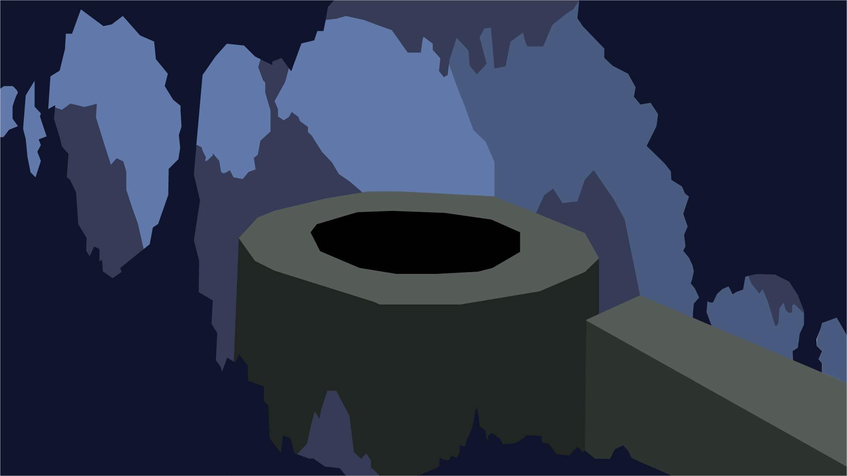

Figure : “Cave inside the mad king castle” Concept Art, Made by Antonino Frazzitta

# User Interface

## Menus

To make the game more accessible to a wider audience of players, we chose the UI font “OpenDyslexic”, made specifically to be easy to read. This means that players will not mistake different interface options making navigation flawless.

The idea of the main menu is to create an atmosphere for the rest of the game. There is a signpost in the foreground with a castle in the background. The signpost is where most of the menu interaction takes place by clicking different boards that link to other menus or start/quit the game.

The aesthetic of our menu is to mirror the dark medieval theme that we chose to use. This is a principle of UX which is The Aesthetic-Usability Effect by researchers Masaaki Kurosu and Kaori Kashimura where they found aesthetically pleasing UI made for a better user experience.

Our UI utilises the law of proximity which states that objects that are near or proximate to each other tend to be grouped together in the mind of the user. This means that with our UI being grouped together in the top left corner of the screen, the user is more likely to understand that this applies to their character as they have learned conventions from previous gaming experiences. The UI being grouped has another function, i.e. the user is taught in our tutorial that the health meter is the orbs and the soul meter is the bar. Knowing this makes the users’ experience much more fluid as they will not need to remind themselves which is which.

We chose to use this UI as it adds to our theme as well as conveys all information the player needs without cluttering the HUD and allowing the player to experience the game without getting in the way.

### Main Menu

This is the first screen that is presented with an in-game animated background where the player can choose between different options.

The submenus will be a chained signpost under the button selected, and when the player selects them, they are revealed.

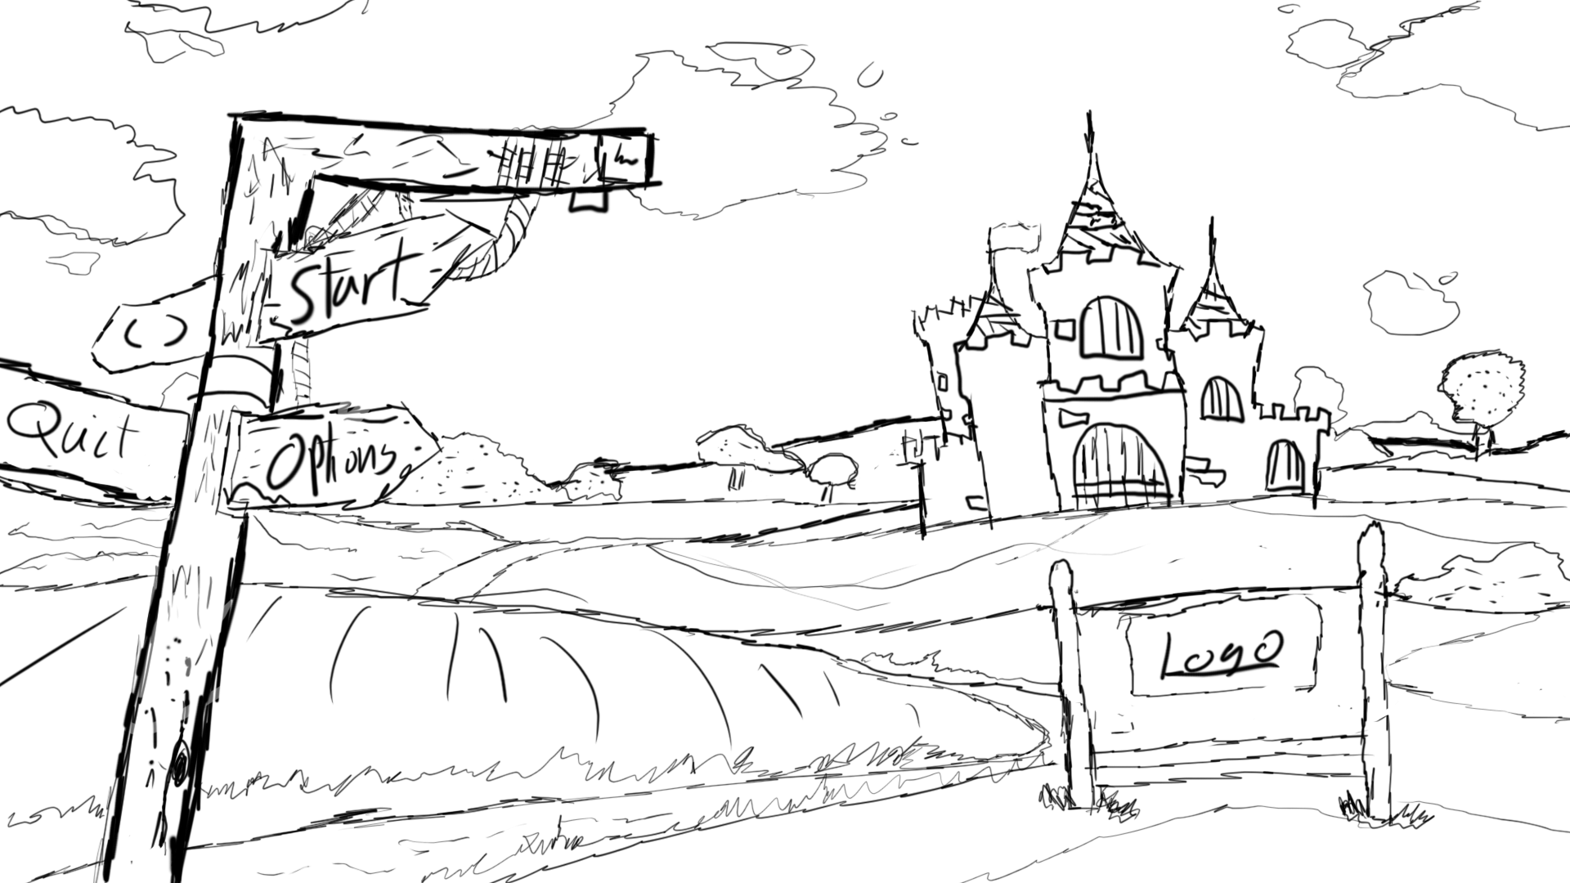

Figure : The main menu

### Continue Submenu

This menu leads into three saves files - the player can load one of them and pick up their game where they left off.

### Option Submenu

Here the player can change the settings of the game, such as volumes, fullscreen and resolution.

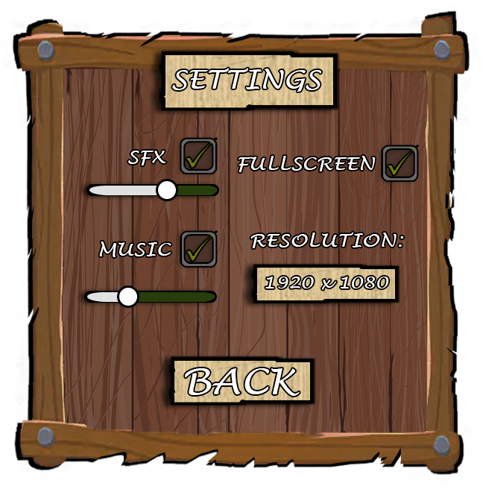

Figure : Option submenu

### Level Intros

Before the level starts, there will be a short intro, narrated in the first person with voice and text that impersonates Jack explaining his feelings through the game progression. There will be some hints about whether the player is taking the Good or Bad story path to provide a narrated feedback without spoiling the ending.

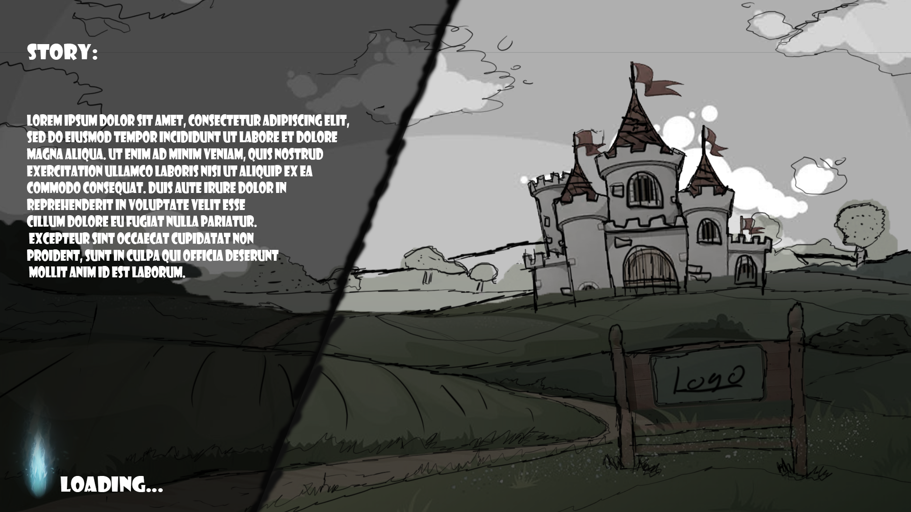

Figure : Level intro page

## HUD

For the HUD we decided to implement visual stimuli to give the player extra feedback with information needed for the gameplay.

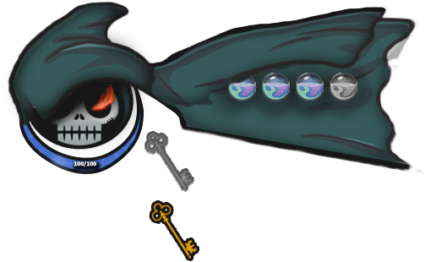

Figure : An example HUD

This minimalistic system it can be divided into:

* **Hit points:** very similar to Zelda heart system, but one hit point is equal to one damage taken by the enemy, which can be any type such as collision or projectile.
* **Soul Energy:** this will determine how much the player can use the magic abilities that can be recovered in different ways.
* **Skull eyes:** the skull eye will be lit when the player has absorbed one of the two abilities. One ability for each eye.
* **Key:** until the player collects the key, it is greyed out. Once it is collected, it appears fully on the HUD.

## Hub Map

The level navigation will be represented in the hub map where the player can pick a level. The map will be a 2D texture on a 3D environment to emphasize the 2.5D feature of the game.

The player can change the pointer of the map by scrolling location markers. The location will be differentiated with landmarks that represent that specific place.

For ease of testing, we will make every level playable from the beginning, but the original idea was to unlock the level based on the story progression.

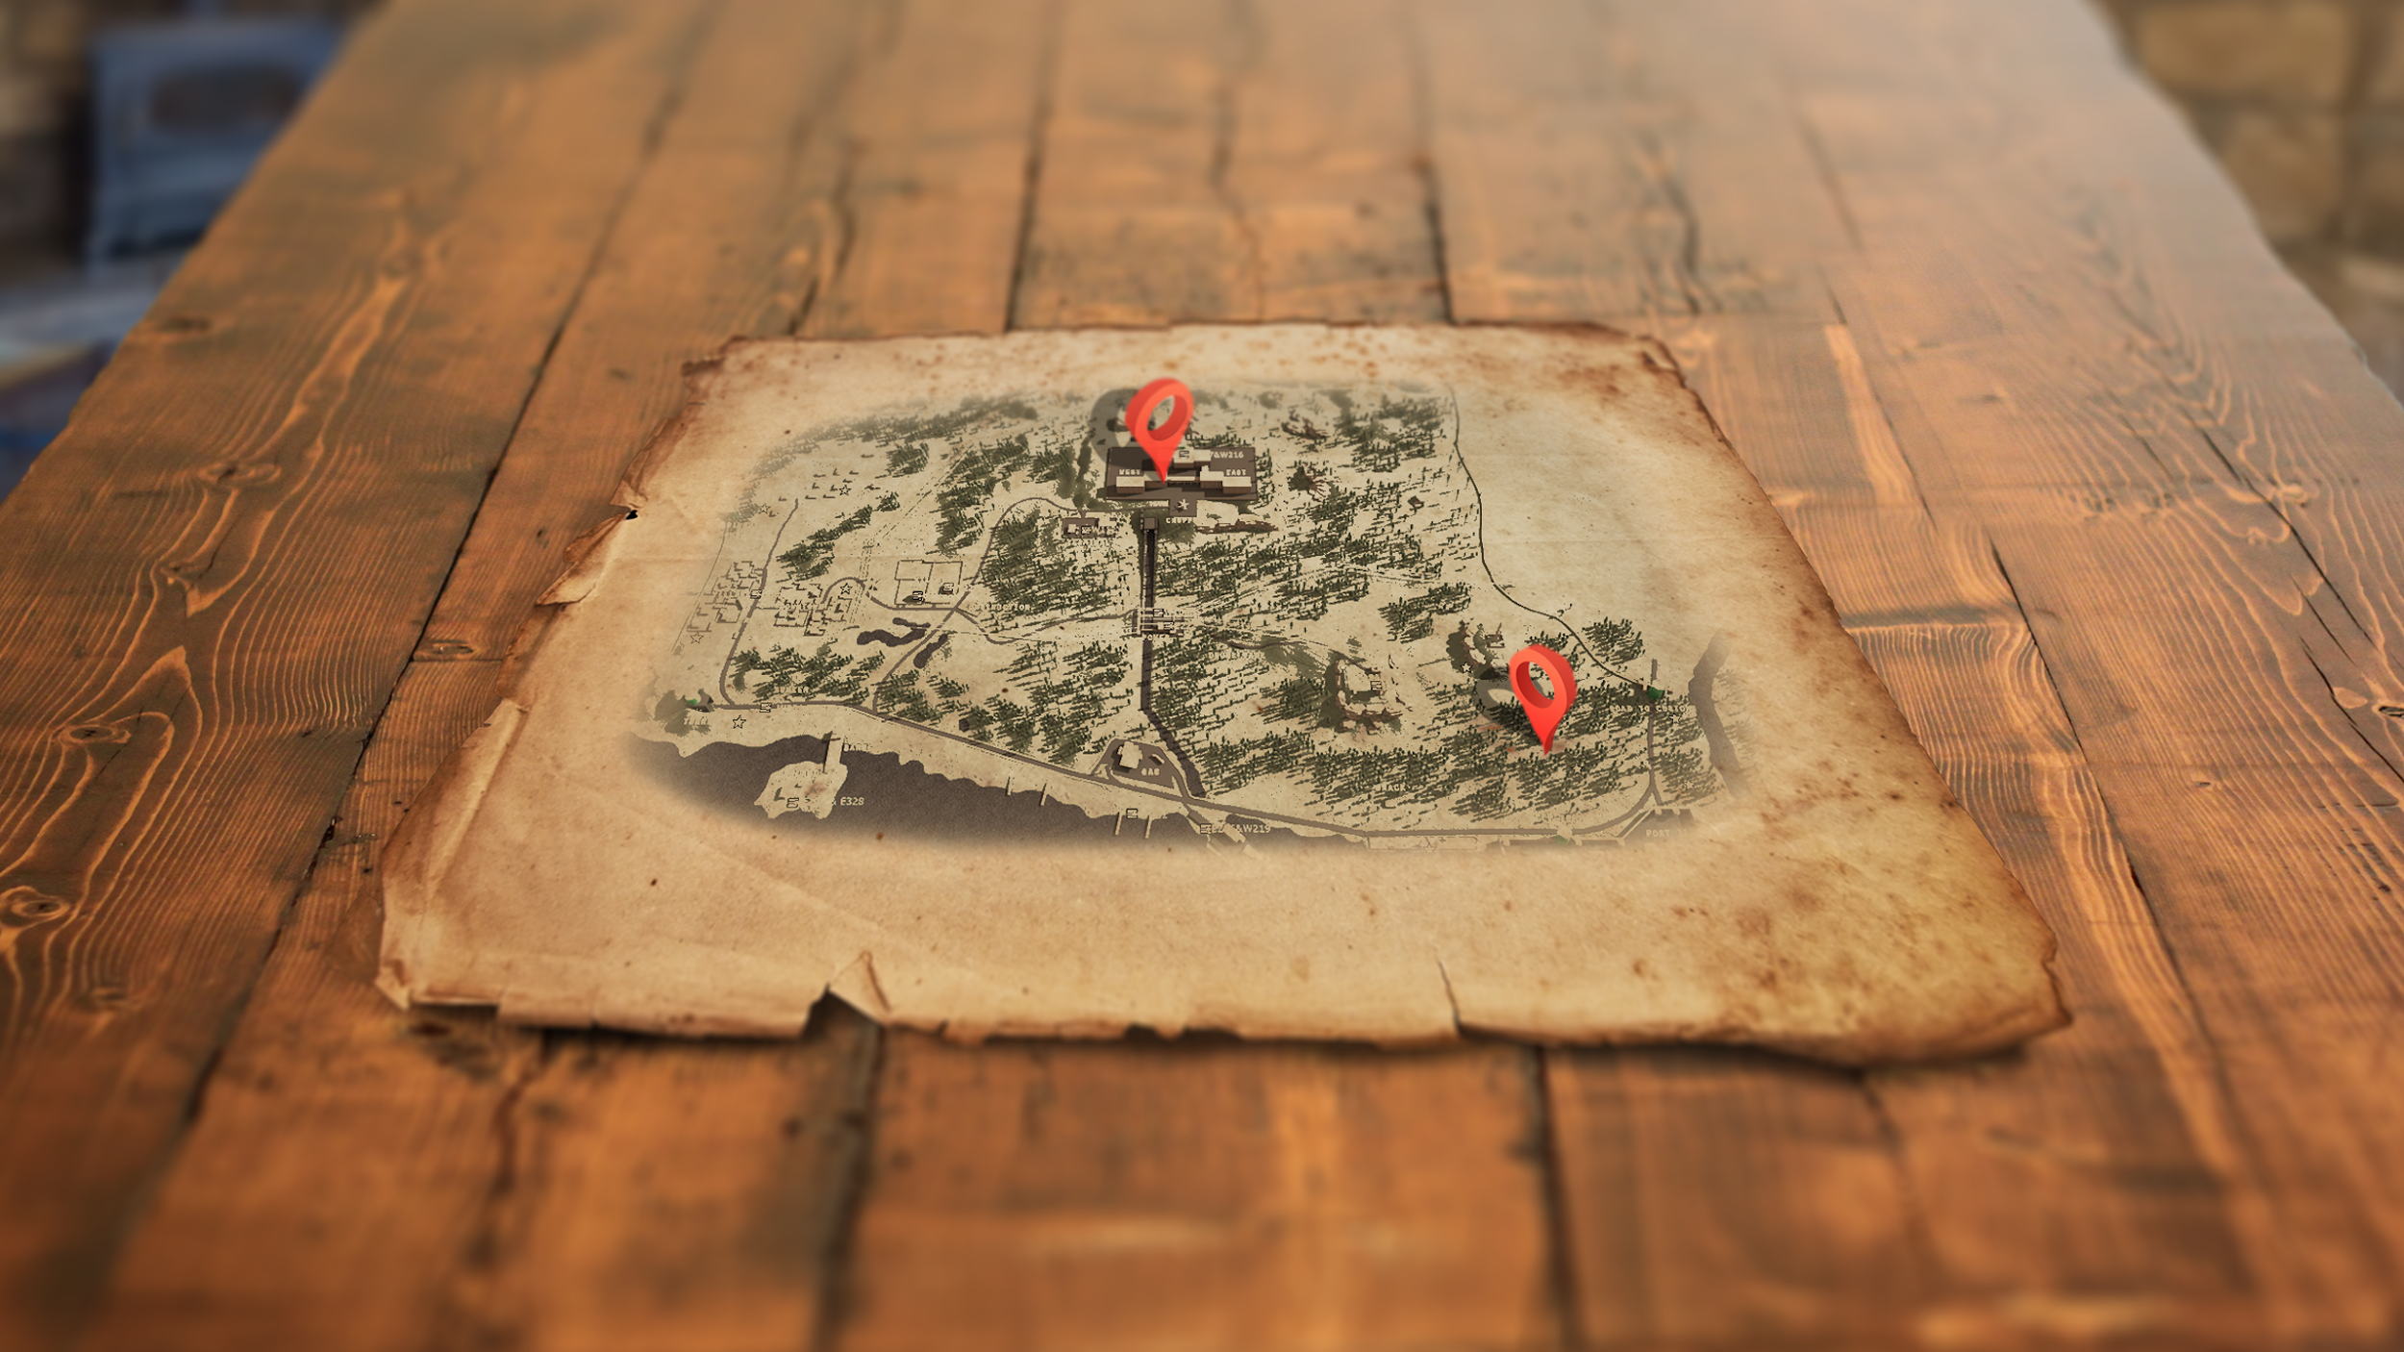

Figure : Example of a hub map

## Screen Navigation Flowchart

### Start Game

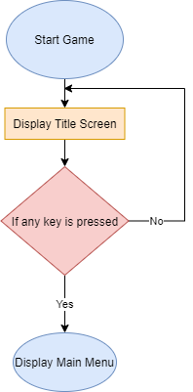

Figure : Flow chart showing the start of the game

### Display Main menu

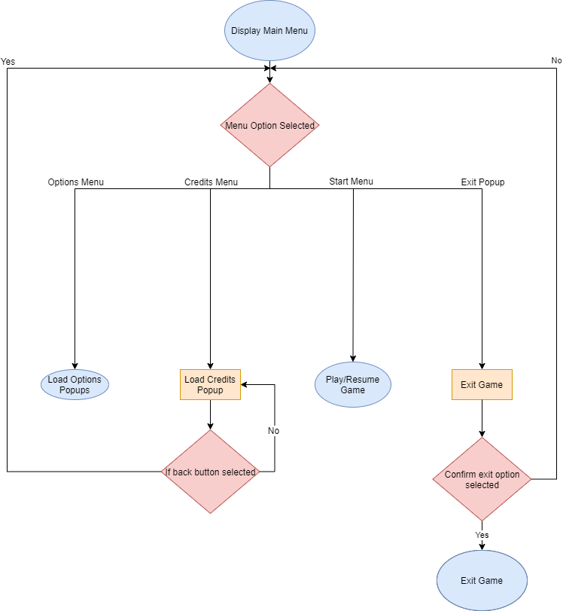

Figure : Flow chart for display main menu

### Play/Resume Game:

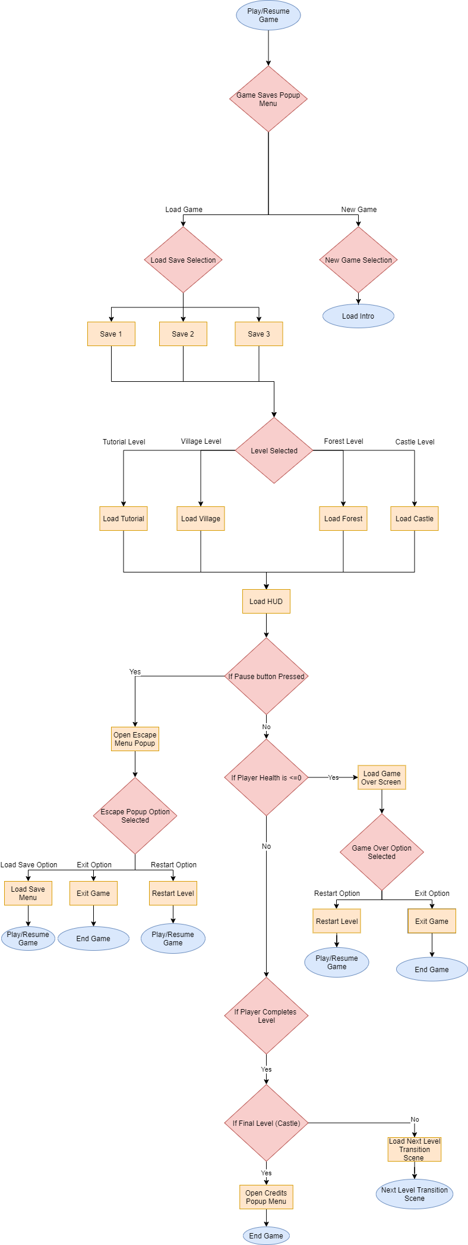

Figure : Flow chart showing play / resume game options

Audio

## Music

We chose not to use copyrighted music in order to make our project look more original and provide an opportunity to really make audio that fits well with the theme of the game.

The music of the game will be a dark theme music, eg. Diablo 1 soundtrack.

We wanted the music in the game to be dark and gloomy to go along with our dark medieval theme, so we requested the music to be different from the tutorial to the boss fight.

The tutorial soundtrack is meant to be slow and calm - a calm before the storm of the main game’s action.

The first level’s theme is faster paced than the tutorial to convey that there is more action happening in the level.

The second level has a spooky, dark and mysterious feel as they are in the forest at night; this will not be calm as it was in the tutorial, but more atmospheric.

Finally, the boss fight’s theme will be more rock style - somewhat like Castlevania. We wanted it to be climatic with three phases and therefore will require three variations as the music will change as the boss’s health gets lower.

## Sounds

We asked a student from music production to help us develop original background music for our project.

These sounds will vary from slashing sounds, arrows, powers, or even movement sounds of the different characters. We want to make the sounds sound inclusive within the world of our game.

* Sword swing
* Dash sound (swish)
* Magic shoot
* Jump leap
* Different monster growls
* Wolf howling
* Magic absorb
* Person mumbling (casting a spell)
* Magic recharge
* Evil Laughs
* Dying scream
* Narrator Voice (Damian)

# Software Testing

We have used a staged approach for our strategy for testing and evaluation. This has commenced with our games software engineer developing a prototype that contained a basic understanding of how the characters and attacks within our game will look like.

The prototype is just a simple level where it displays different enemies and how they react to the player; for example, the enemy runs away from the player to gain distance so that it can then shoot their projectile. This prototype also shows how the player attacks and his abilities. We used this prototype to also have a notion of how our character would move within the level how high it could jump or how fast it should move.

Using this prototype has enable us to test and evaluate our initial game concepts before progressing to the final design.

At the next stage of development, we have identified several phases of testing as each level is completed, with a final test of the whole game (see Gantt chart in section 15.1). In addition, we will undertake stage reviews as we complete each milestone (e.g. completion of level 1) to ensure that all the component parts of the game work cohesively. These reviews will include all team members.

# Possible game extensions

We decided to introduce some extra content into the game through “DLCs”. This would aid the re-playability of the game, as it will enable us to easily add pieces to a bigger scale “puzzle”.

We are aware that our game will not necessarily be played more than twice for the two endings, so we want to extend the playtime by expanding the content. This can be done by adding new levels, new monsters, new bosses, abilities and new antagonists for the story to be extended.

* **True ending:**  the player has to finish the game with both routes to get the real ending of the story.

# Risk Assessment

|  |  |  |
| --- | --- | --- |
| **Risk?** | **Prevention and fall back?** | **Have we done this?** |
| The files become corrupt. | Have an extra save file for my work. | Yes, I also have saved in the cloud and on a portable drive. |
| Overwritten save files. | Versioning. Create a new save file after every lesson. | Yes |
| Program crashes while working. | Save after any changes made, have autosave turned on. | Yes |
| Losing/Misplacing files. | Save the files in appropriately named folders. | Yes |
| Not saving my work when I’m finished. | Save throughout and double save when I’m finished. | Yes |
| Unable to work from due to not having the software I need. | Download the software at home, ensure up to date. Come onto campus and work form labs if unable to work from home. | Yes |
| Absent for meetings | Try and push each member to attend each meeting. If they are unable to attend, minutes of the meeting are typed up and added to the drive so that they can be accessed remotely, and the member can catch up to speed. | Yes |

# The Team

## Team Roles

|  |  |  |
| --- | --- | --- |
| Team member | Role | Tasks |
| Damian Hunt | Narrative Director/Character Designer |  |
| James Mitschke | Lead Programmer |  |
| Paulo Faria | Level Designer |  |
| Antonino Frazzitta | Art Director |  |
| Tia Nue | Gameplay Director |  |
| Daniel King | Developer |  |
| Elliot Ainscough | Project Manager |  |
| Oliver Perkins | UI Designer/Creator |  |

## Meetings and Minutes

| **Date of Meeting** | **Who Attended?** | **What was Discussed?** |
| --- | --- | --- |
| 03/02/20 | Daniel, Antonino, Elliot, Paulo, Damian, Tia | * Very basic concepts for what the game could be in terms of genres and what game engine it should be built on * Gaining more team members as we were only 4 designers originally   + Then meet up with 2 other designers looking to join a team and recruited them into the team     - Damian Hunt     - Tia Nue   + Started communicating with a potential software engineering student (James Mitschke) * Finished our team’s first meeting with giving everyone the task of coming up with a presentable game concept they want to go with   + Deadline set for the next meeting (05/02/20)   + Engine chosen was Unity |
| 05/02/20 | Daniel, Antonino, Elliot, Paulo, Damian, Tia, James | * Started meeting by presenting all of our game concepts (excluding James as he joined the team off this meeting)   + **Dan**: 3D FPS Alien Shooter set in the future with 3 different levels with the final one being a boss battle.   + **Elliot**: “Doom-Style” 3D FPS set in the not too distant future where aliens take the player character’s wife and the player must fight to get her back. With very fast-paced gameplay, the player collects different weapons and traverses unique multi-layered levels (multiple elevations).   + **Paulo**: 2D stealth platformer with a unique physics-based trash mechanic. The player collects valuable items through the levels, while avoiding guards, and can use it to distract them or stun them by throwing it.   + **Damian**: 2D platformer with a “Witcher-like” choice system set in a fantasy world where twisted creatures are “trapped souls” and were once human. The player character acts as a “Soul Hunter” with a morality system shaping the kind of hunter they are (good/neutral/bad). Hack and slash combat.   + **Tia**: A 3D First-Person action, speedrunning platformer, inspired by Karlson, set in modern times around offices.   + **Antonino**: Wanted to focus on the mechanics of the chosen game rather than the overall concept. Wanted a game with;     - 3 different levels     - Enemies separated into classes     - treasures “collectables”     - Special abilities attached to losable armour -> e.g. boots that make the player jump higher     - Good level pacing -> “slow” rest points in between levels     - Player Agency being the focus * Ended the meeting with coming up with a partial final game idea by combining ideas together   + 2.5D style -> 2D Characters and 3D Environment   + Platformer   + Simplistic hack and slash   + Core mechanics     - Upgrading moveset     - Morality System   + Movement -> Character can move right/left, jump up, and dash in any of those directions |
| 10/02/20 | Daniel, Antonino, Elliot, Paulo, Damian, Tia, James | * For this meeting, we tried to focused on talking about the game visually, what we thought it could look like * Player dash ability   + dash in the direction the character is facing -> left, right, up   + Attacks also work in the same way * Character   + Combat done mainly using a sword, slashing in the direction the player is faced * We also defined the necessary team roles   + Narrative Director -> Damian   + Lead Programmer -> James   + Level Designer -> Paulo   + Art Director -> Ant   + Gameplay Director -> Tia   + Developer -> Daniel King   + Project Manager-> Elliot |
| 12/02/20 | Daniel, Antonino, Elliot, Paulo, Damian, Tia, Oli | * Started the meeting by introducing a new, and our last, team member, Oli   + Oliver Perkins -> UI Designer/Creator * James mentioned he wouldn’t be available for this meeting beforehand * Some boss battle designs were drawn and explained by Antonino how it should work different from the rest of the game   + 3D Boss with the player running around it avoiding big attacks-> e.g. hands * Narrative   + Further discussion on how we would tell the narrative of the game without any text dialogues   + 2 Defined characters -> Dustin (Jack’s Father) and Jack (Player Character)   + Introduction scene giving background to the game world and characters * Gameplay   + Shooting Ability   + Dash Ability   + Both abilities targeted in 3 directions     - up, left and right * Mini Bosses/Boss Battle   + Defined the first mini boss that gives the player the dash ability, if they choose to harvest their soul for it     - Werewolf -> Village Level 1   + Revolving boss battle boss room     - Player can freely move along the z axis * Level Design   + Introduction Animated Scene (Lore)   + Level 1 -> Village (Werewolf)   + Level 2 -> Forest   + Level 3 -> Cave (Boss Battle) * Art Style   + 2D Chibi style characters and enemies   + Simplistic 2D scrolling background   + 3D environment “Static mesh details” * UI Design   + Overworld level select/transition   + Reactive UI -> When player making moral choice, UI reflects each choice     - Harvest = Option Highlights in Red     - Save = Option Highlights in White     - Surrounding effects for each |
| 17/02/20 | Daniel, Antonino, Elliot, Paulo, Damian, Tia, Oli | * Apologies: James Mitschke * The focus for this meeting was the design document * Started and ended by reading through as much of the document as we could get through in the 2 hours, all-the-while questioning and changing things to get the design back on track   + Ended on the Narrative section * Defined 3 similar games to go and do target audience research around   + Don’t Starve   + Valiant Hearts: The Great War   + Hollow Knight * Talked a lot about what the theme of the game should be   + Went on using the reference material Nightmare Creatures, for its gothic style and Darkest Dungeon and Castlevania for their environments   + Set the tone down to the player’s actions as they can choose to be good or evil * Narrative   + As the only form of dialogue in the game, the narrator would be the player’s “subconscious”   + All other hints and storytelling would be found in each level’s environment as background scenery or intractable “newspapers, etc. * Synosis   + Discussed the basic story and Jack’s quest to save their kidnapped adopted sister Verity which the player meets in the prologue * Gameplay   + Some big design changes were decided to make the game buildable within our timeframe   + Removed the idea of secondary quests making the game more linear   + Can interact with NPCs but cannot kill them, plays an animation * Ended the meeting with setting everyone the task of reading the document and coming up with improvements |
| 19/02/20 | Daniel, Antonino, Elliot, Paulo, Damian, Tia, Oli | * Apologies: James Mitschke * Discussed a variety of different sections in the document * Target audience   + Revealed what our target audience was (age, gender, etc) * Game theory needed to back up most of the document (our design decisions) going back to GDP for things like state of flow   + Planned continued support of the game through DLC * Feedback systems   + Hitting enemy makes it flash a colour   + No enemy health bar, but their model changes depending on how much damage they have taken   + Discussed adding in emojis for when the player interacts with NPCs * Controls   + Keyboard only layout   + Mouse and Keyboard layout * Target Length of Game   + 10 Minutes * Level Design   + 2 different versions of the forest level     - 1 is the prologue/tutorial and the other is the forest in “present” time * UI   + Level Select Overworld Map   + Main Menu Design by Oli with a signpost having the different options on different signs * Game Story Flow   + Discussed the time skip between the the prologue and village levels * Ending   + Regardless of the player’s choice, the mad king dies     - Killing them-> King dies     - Spare them -> King kills himself * Ended meeting with individual role-specific tasks to do for the next meeting |

# Planning and Gantt chart

The planning for the game was quite rigorous as we have people from different groups as well as different courses working together on this project. Our first plan was to have two meetings a week which would take roughly two hours to cover all aspects of the game. In these meetings we came up with the idea for the game and roles for each member.

We decided that when we came to make our project, an AGILE type of structure would work best for our group, as the short sprints getting one level done at a time working to meet key deadlines, would help us spread out the workload and start earlier on the development process.

Before preparing the Gantt chart, we agreed the key tasks that needed to be performed and an estimate of time that each task would take. We also agreed the number of hours that each team member would contribute each week, taking into account additional activities such as assignments for other courses, reading week etc.

## Gantt Chart

The Gantt chart below shows how we intend to produce he game. We have divided the tasks into logical groups (art design, programming etc) and assigned an owner to each task. The key members who own a task are going to delegate sub-tasks to members who have not been assigned actions (‘floating team members). This will help the critical path for our game and avoid members waiting for assets or code in order to finish a level.

The Gantt chart also shows our regular team meetings when each team member will report progress and, if necessary, reassign ‘floating team members’ to critical tasks to ensure that we meet the project deadline.

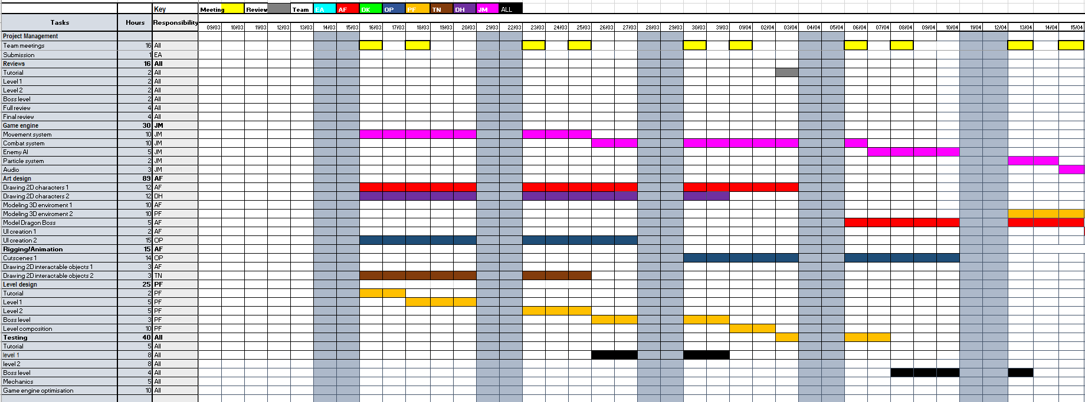

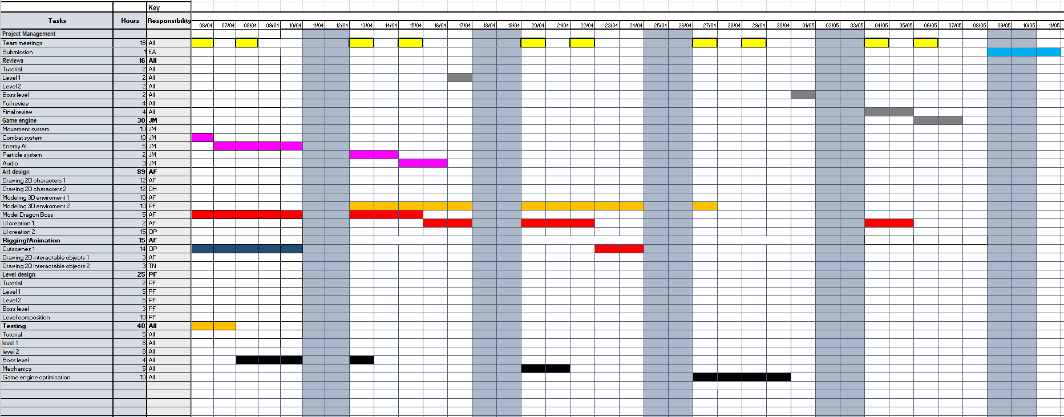

# 

# References

* Suckling, M. and Walton, M., 2016. *Video game writing: From macro to micro*. Stylus Publishing, LLC.
* Adams, E. and Rollings, A., 2006. *Fundamentals of game design (game design and development series)*. Prentice-Hall, Inc..
* Fullerton, T., 2014. *Game design workshop: a playcentric approach to creating innovative games*. CRC press. Research Method
* Target audience
  + Carroll, J., 2020. *How To Research Your Next Game's Target Audience For Free*. [online] Gamasutra.com. Available from: https://www.gamasutra.com/blogs/JustinCarroll/20170313/258979/How_to_Research_Your_next_Games_Target_Audience_for_Free.php [Accessed 20 February 2020].
  + Facebook Audience Insights. 2020. *Audience Insights*. [online] Available from: https://www.facebook.com/ads/audience-insights [Accessed 20 February 2020].Christina Newberry How to Define Your Target Market: A Guide to Audience Research, hootsuite
  + Newberry, C., 2020. *How To Define Your Target Market: A Guide To Audience Research - Hootsuite Social Media Management*. [online] Hootsuite Social Media Management. Available from: https://blog.hootsuite.com/target-market [Accessed 20 February 2020].
* Team Cherry, Hollow Knight,
  + Cherry, T., 2020. *Hollow Knight Steam-Page*. [online] Store.steampowered.com. Available from: https://store.steampowered.com/app/367520/Hollow_Knight [Accessed 20 February 2020].
  + Steamcharts.com. 2020. *Hollow Knight - Steam Charts*. [online] Available from: https://steamcharts.com/app/367520#All [Accessed 20 February 2020].
  + Similarweb.com. 2020. *Team Cherry.Com.Au Analytics*. [online] Available from: https://www.similarweb.com/website/teamcherry.com.au [Accessed 20 February 2020].
  + Hollowknight.com. 2020. *Hollow Knight – An Atmospheric Adventure Through A Surreal, Bug-Infested World*. [online] Available from: https://hollowknight.com [Accessed 20 February 2020].
* Ubisoft Montpellier, Ubisoft, Valiant Hearts: The Great War
  + Steamcharts.com. 2020. *Valiant Hearts: The Great War™ / Soldats Inconnus : Mémoires De La Grande Guerre™ - Steam Charts*. [online] Available from: https://steamcharts.com/app/260230#All [Accessed 20 February 2020].
  + Store.steampowered.com. 2020. *Valiant Hearts: The Great War™ / Soldats Inconnus : Mémoires De La Grande Guerre™ On Steam*. [online] Available from: https://store.steampowered.com/app/260230/Valiant_Hearts_The_Great_War__Soldats_Inconnus__Mmoires_de_la_Grande_Guerre [Accessed 20 February 2020].Similarweb.com. 2020. *Ubisoft.Com Analytics*. [online] Available from: https://www.similarweb.com/website/ubisoft.com [Accessed 20 February 2020].
  + Ubisoft.com. 2020. *Valiant Hearts*. [online] Available from: https://www.ubisoft.com/en-gb/game/valiant-hearts [Accessed 20 February 2020].
* Keli Entertainment 505 Games - Don’t Starve
  + Store.steampowered.com. 2020. *Don't Starve On Steam*. [online] Available from: https://store.steampowered.com/app/219740/Dont_Starve [Accessed 20 February 2020].
  + Klei.com. 2020. *Don't Starve | Klei Entertainment*. [online] Available from: https://www.klei.com/games/dont-starve [Accessed 20 February 2020].
  + Similarweb.com. 2020. *Klei.Com Analytics*. [online] Available from: https://www.similarweb.com/website/klei.com [Accessed 20 February 2020].
  + Steamcharts.com. 2020. *Don't Starve - Steam Charts*. [online] Available from: https://steamcharts.com/app/219740#All [Accessed 20 February 2020].
* Images Used
* Keli Entertainment 505 Games Don’t Starve
  + Upload.wikimedia.org. 2020. [online] Available from: https://upload.wikimedia.org/wikipedia/en/d/d2/Don%27t_Starve_cover.jpg [Accessed 20 February 2020].
  + Klei.com. 2020. [online] Available from: https://www.klei.com/sites/default/files/games/dont-starve/gallery/ds13.png [Accessed 20 February 2020].
* Ubisoft Montpellier, Ubisoft, Valiant Hearts: The Great War
  + Cdn02.nintendo-europe.com. 2020. [online] Available from: https://cdn02.nintendo-europe.com/media/images/10_share_images/games_15/nintendo_switch_4/H2x1_NSwitch_ValiantHeartsTheGreatWar_enGB_image1600w.jpg [Accessed 20 February 2020].
  + Ubistatic19-a.akamaihd.net. 2020. [online] Available from: https://ubistatic19-a.akamaihd.net/ubicomstatic/en-GB/global/media/VH_Screenshot_5_PCDL_158538.jpg [Accessed 20 February 2020].
* Team Cherry, Hollow Knight
  + Cdn02.nintendo-europe.com. 2020. [online] Available from: https://cdn02.nintendo-europe.com/media/images/10_share_images/games_15/wiiu_download_software_5/H2x1_WiiUDS_HollowKnight_image1600w.jpg [Accessed 20 February 2020].
  + Steamcdn-a.akamaihd.net. 2020. [online] Available from: https://steamcdn-a.akamaihd.net/steam/apps/367520/ss_f1f594e1057a124d289a5905b53b5a0f820982c0.jpg?t=1577747500 [Accessed 20 February 2020].
* Studio MDHR Entertainment Inc. CupHead
  + I.redd.it. 2020. *Easy Mode Tutorial*. [online] Available from: https://i.redd.it/xnrezkjgailz.jpg [Accessed 15 February 2020].
* Kurosu, M., & Kashimura, K. (1995). Apparent Usability vs. Inherent Usability*. Conference companion on Human factors in computing systems - CHI '95.*
* cf. Gray, Peter O. (2006): *Psychology*, 5th ed., New York: Worth, p. 281. [ISBN](https://en.wikipedia.org/wiki/International_Standard_Book_Number) [978-0-7167-0617-5](https://en.wikipedia.org/wiki/Special:BookSources/978-0-7167-0617-5)
* Campbell, J., 2008. *The hero with a thousand faces* (Vol. 17). New World Library.
* Csikszentmihalyi, M. and Csikszentmihalyi, I.S. eds., 1992. *Optimal experience: Psychological studies of flow in consciousness*. Cambridge university press.
* Art Rocket. 2020. *Easy Steps To Creating Chibi Characters*. [online] Available from: https://www.clipstudio.net/how-to-draw/archives/155423 [Accessed 14 February 2020].